**CompTIA Linux+: Troubleshooting**

# Chapter 1: Course Overview

## Chapter 1.1: Course Overview

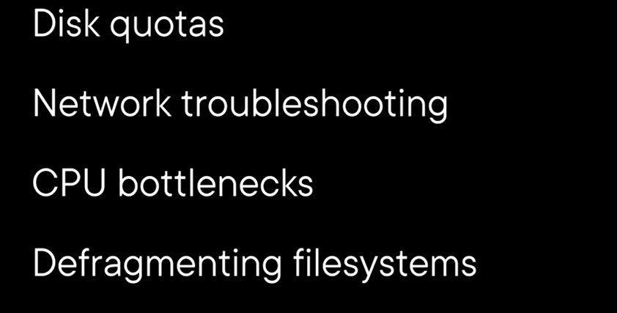

# Chapter 2: Troubleshooting Networks

## Chapter 2.1: Welcome to Troubleshooting

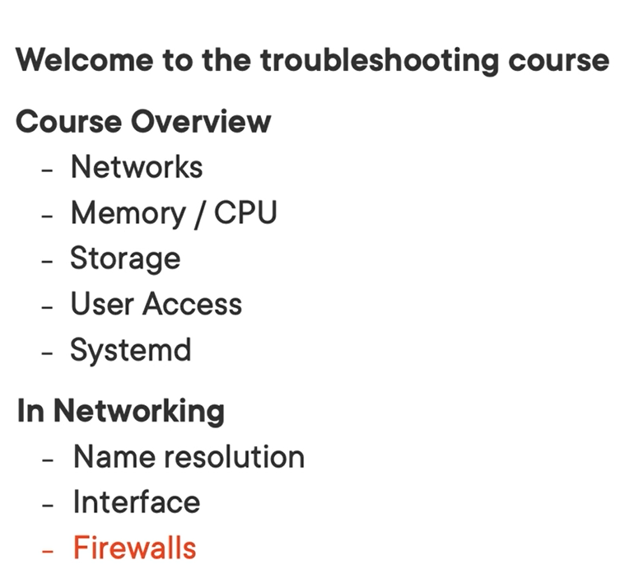

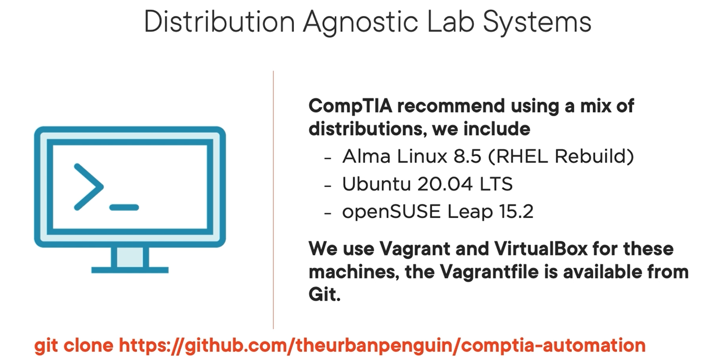

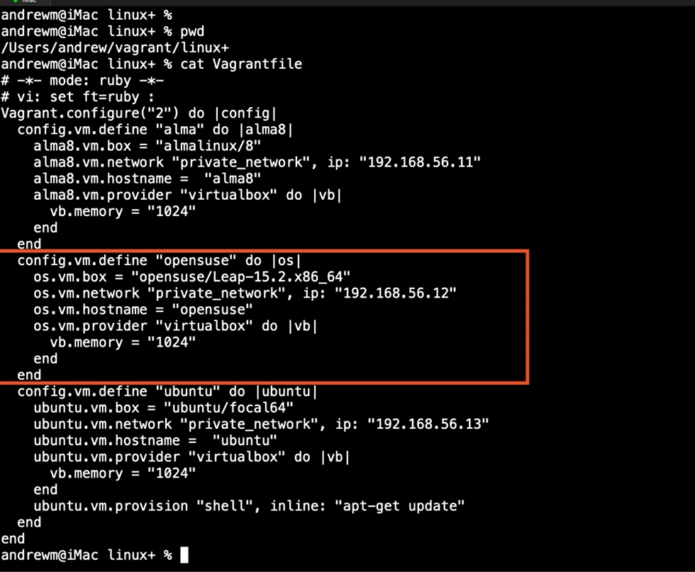

Vagrant up

Vagrant ssh alma

Hostnamectl

## Chapter 2.2: Dropped Packets on Network Interface Card (NIC)

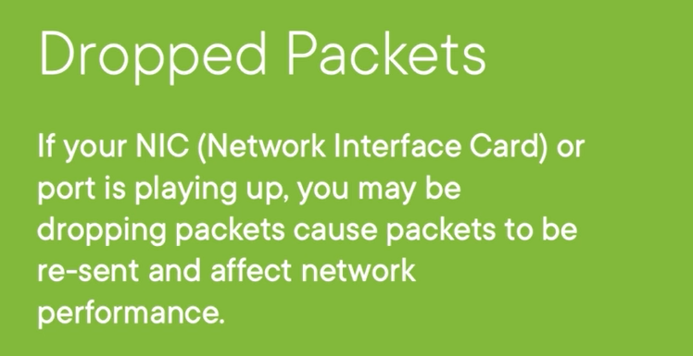

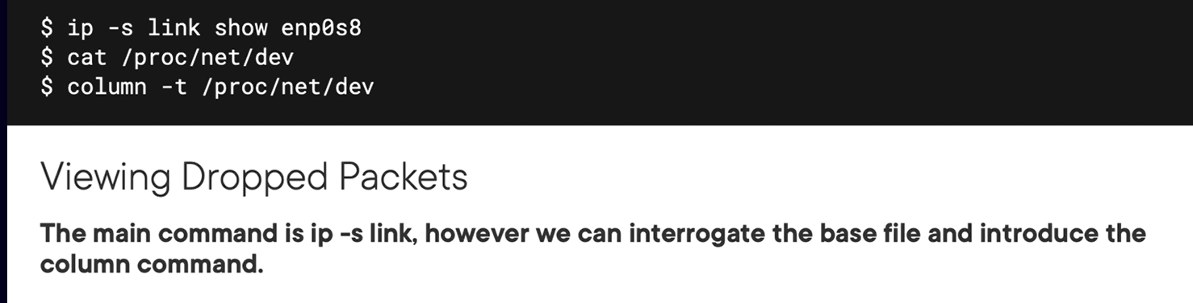

Demo

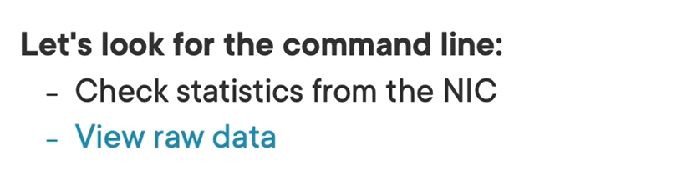

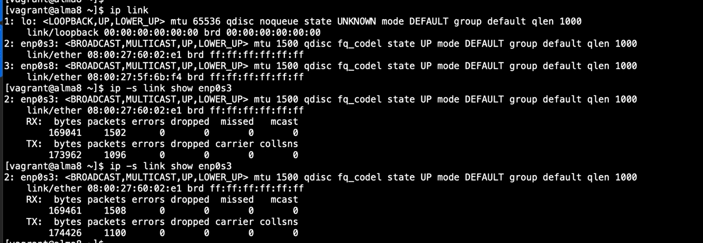

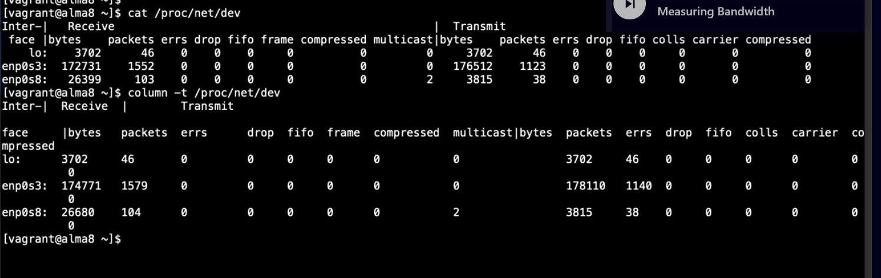

## Chapter 2.3: Measuring Bandwidth

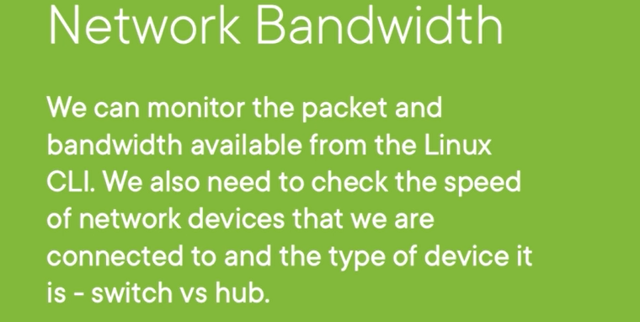

Monitoring bandwidth use nload

Monitoring configuration or viewing speed of a NIC use ethtool

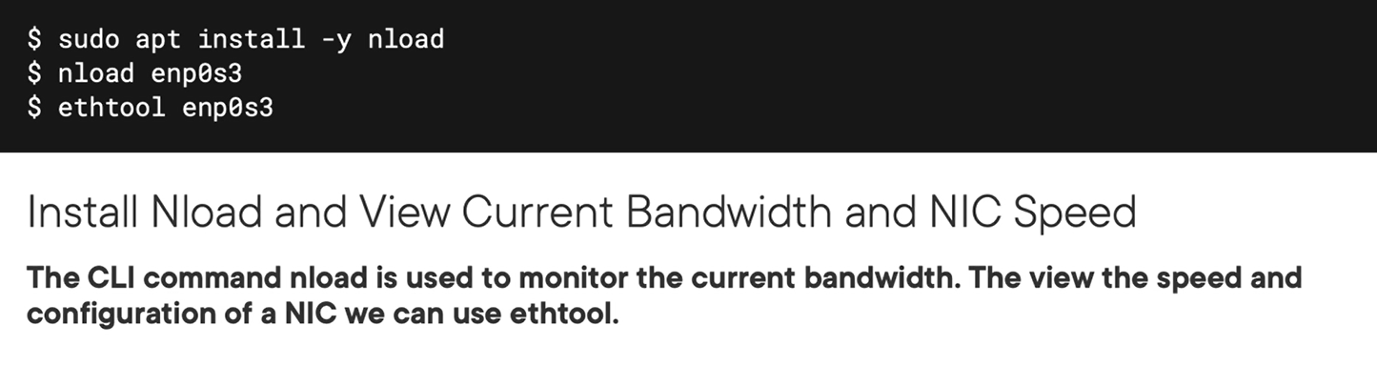

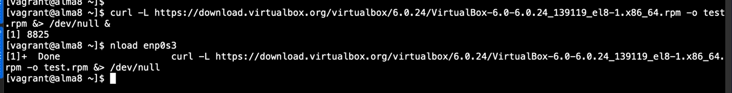

## Chapter 2.4: Working with Domain Name System (DNS) and Resolvectl

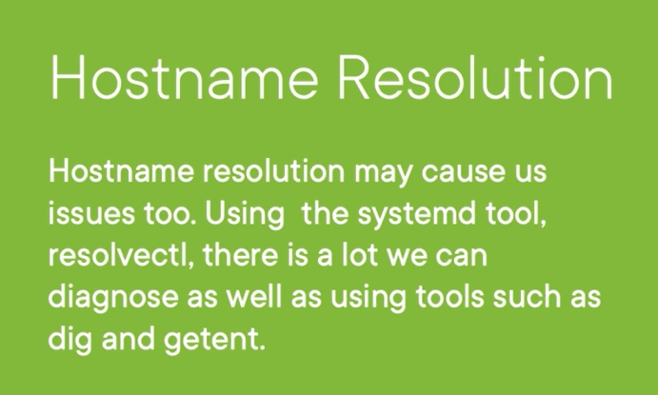

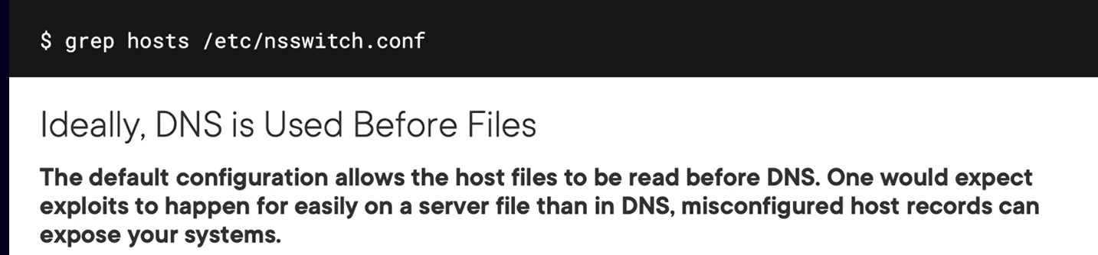

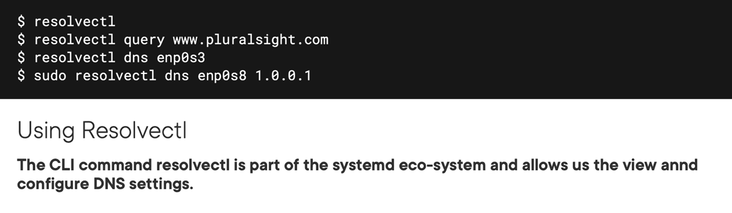

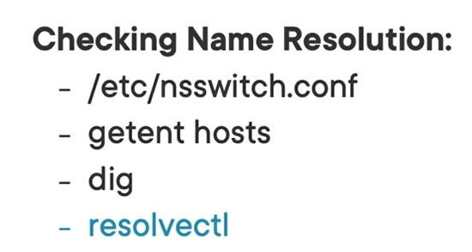

Checking resolve order on system

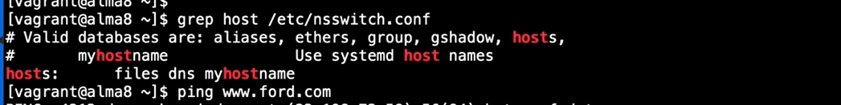

You Should change the order at bellow:

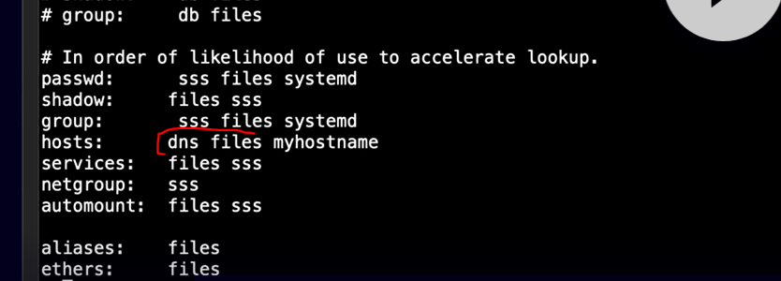

You will get result form the localhost with “getent hosts”

But the genuine result with “getent hosts ford.com” although you already set in localhost for ford.com with private IP.

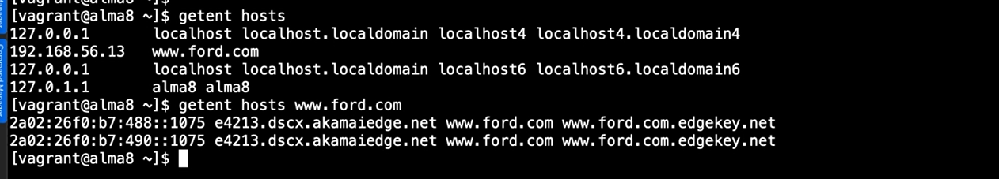

Resolvectl appear on ubuntu default. And it will query to local dns first.

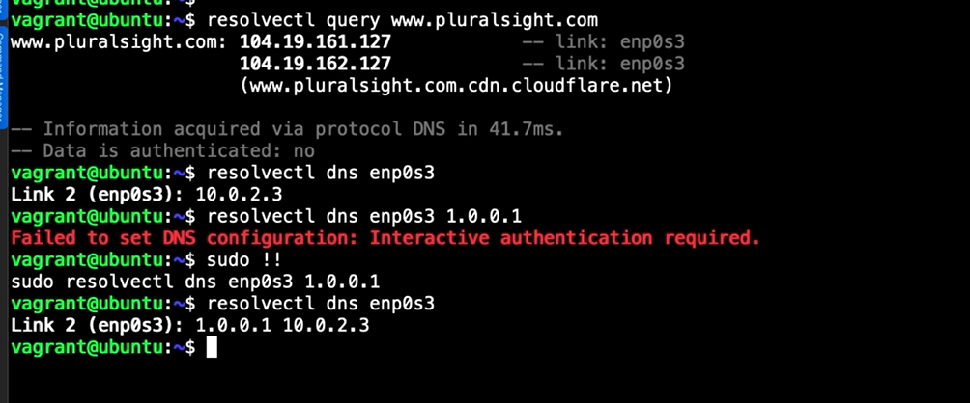

Dig

You will see result query of cnet.com is local dns first. So you can specific certain dns which you want.

## Chapter 2.5: Understanding Tools to Test Network Access

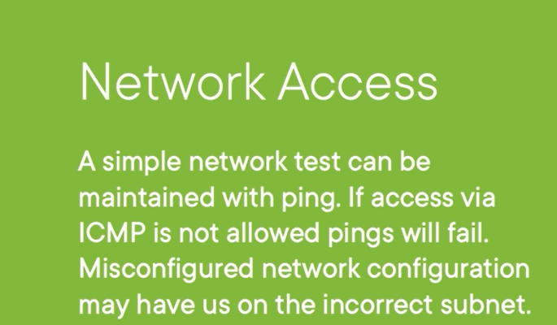

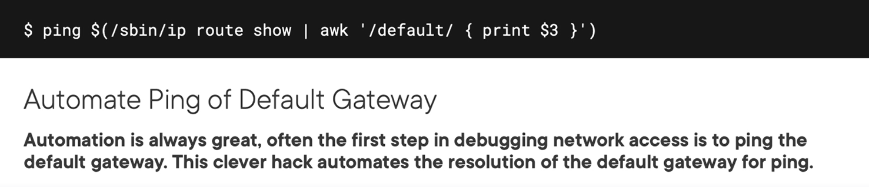

Tip:

You can omit midle octe if it is zero

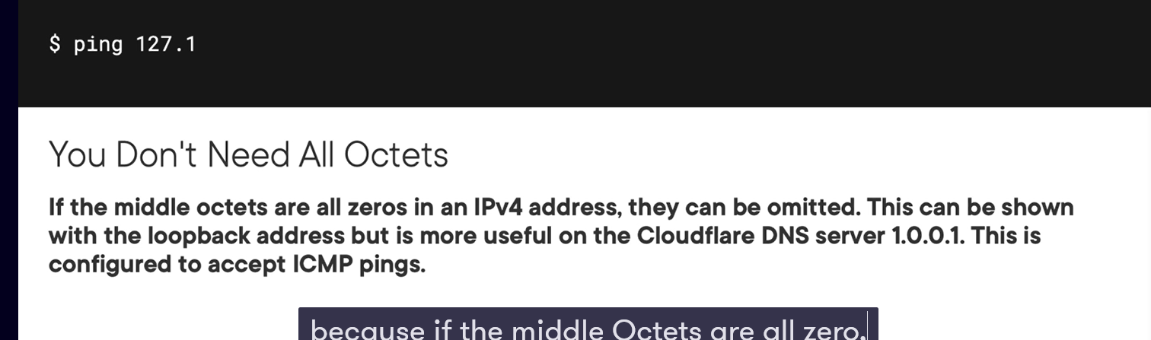

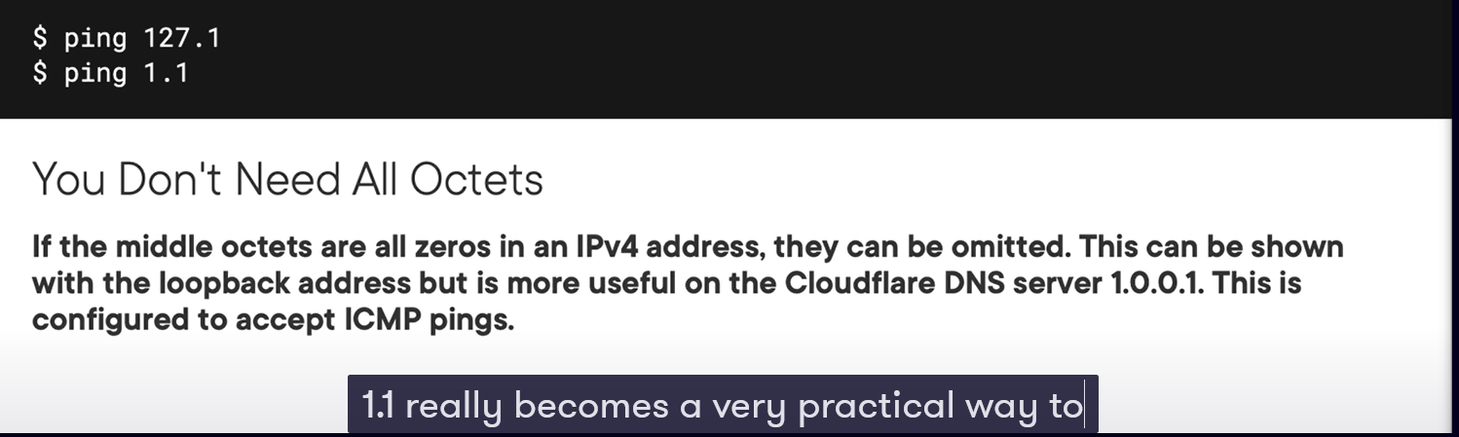

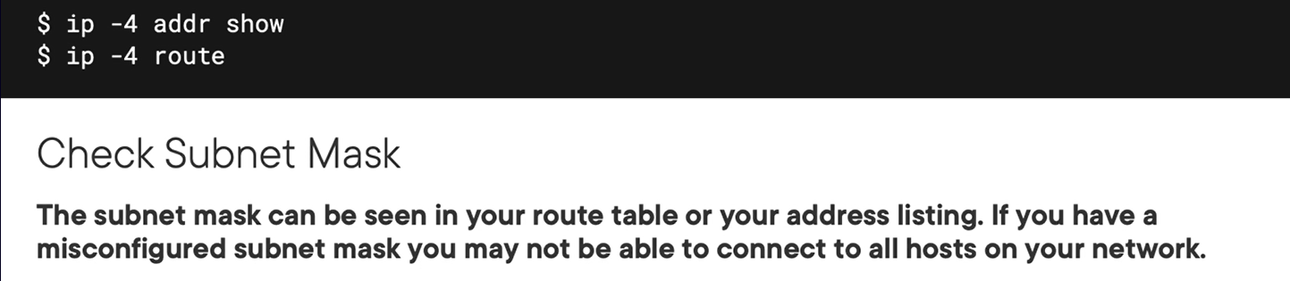

You can use nmap tool for scanning open port if icmp being disabled

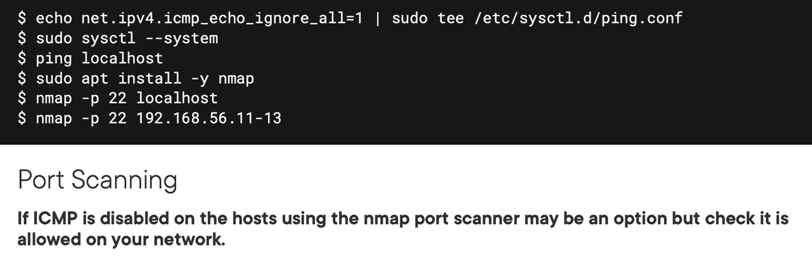

## Chapter 2.6: Testing Access to the Network

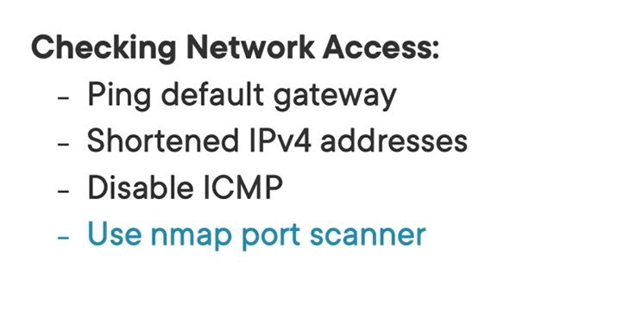

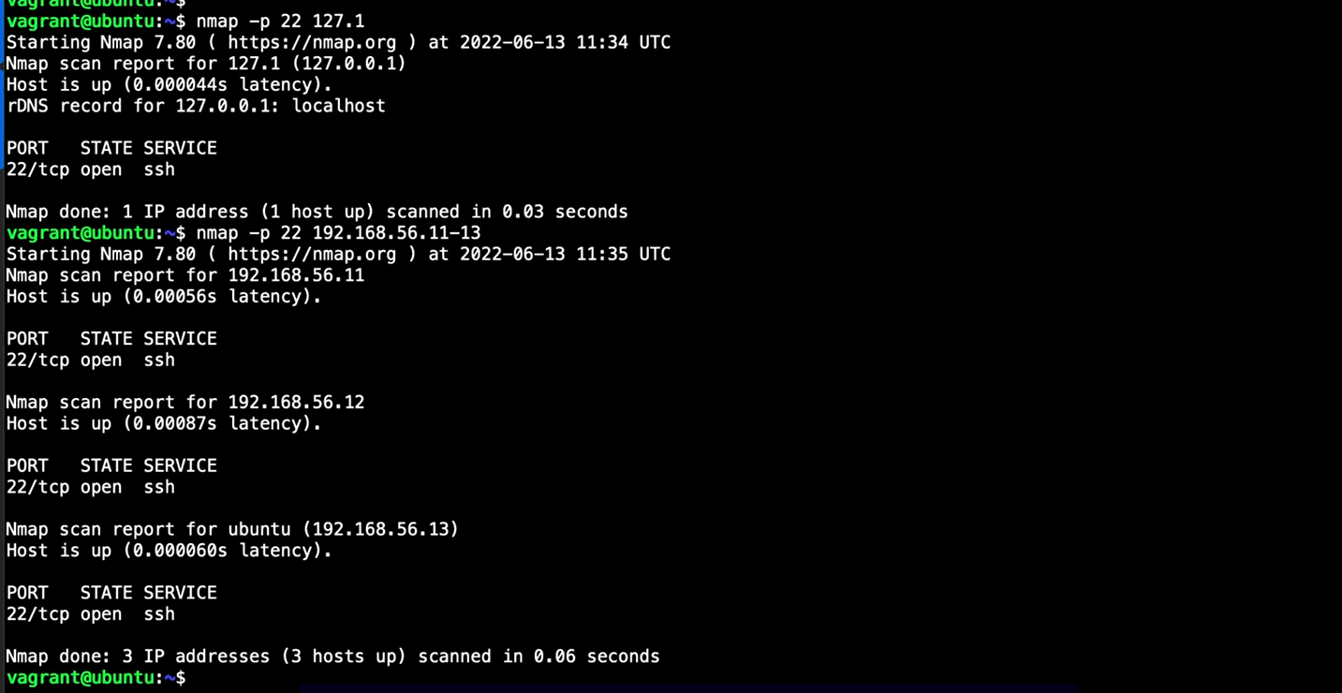

## Chapter 2.7: Testing Firewalls Issues

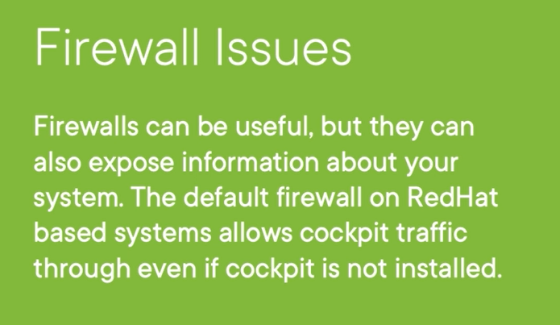

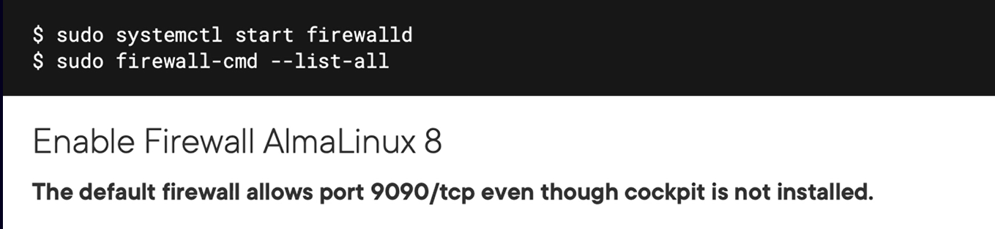

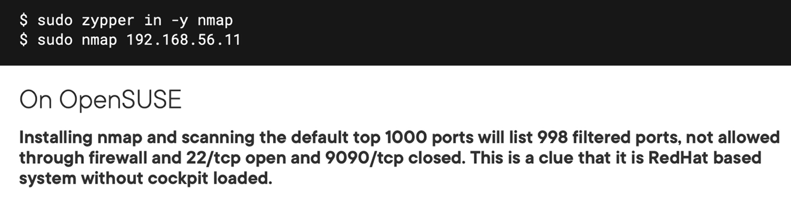

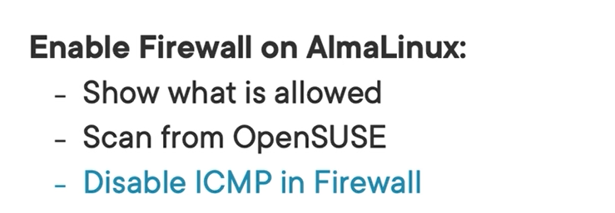

Demo

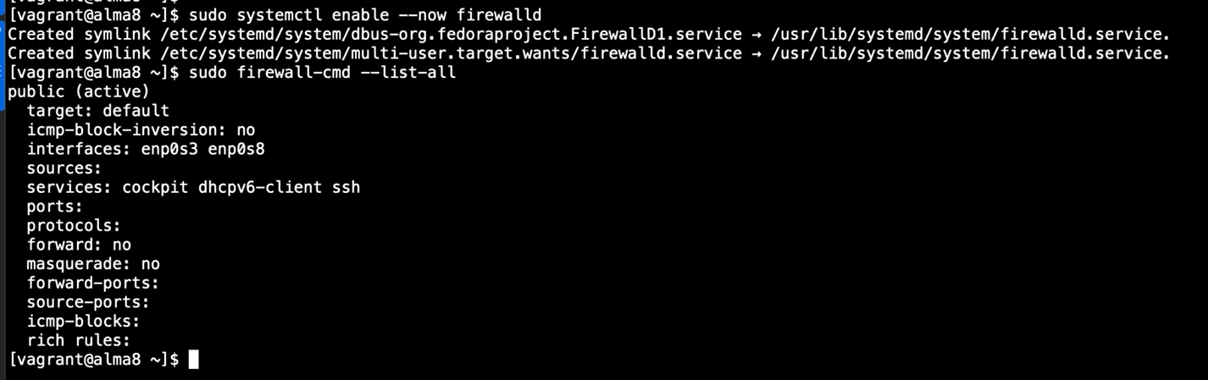

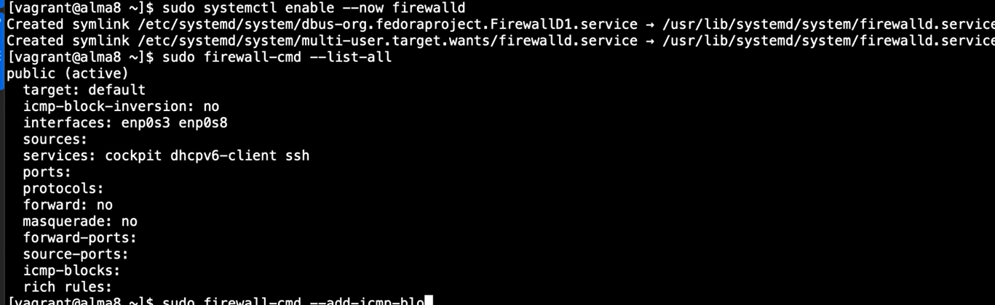

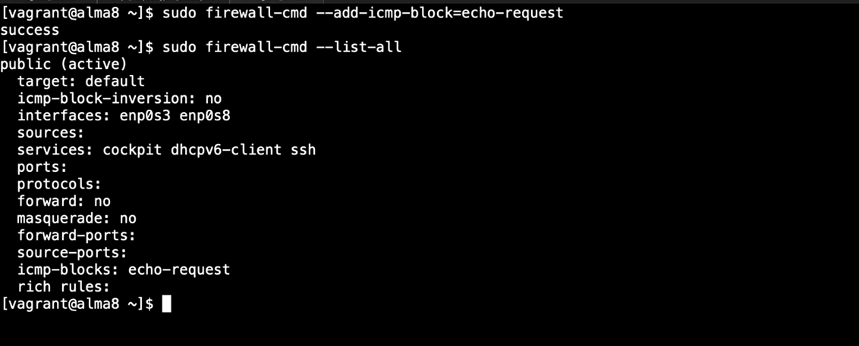

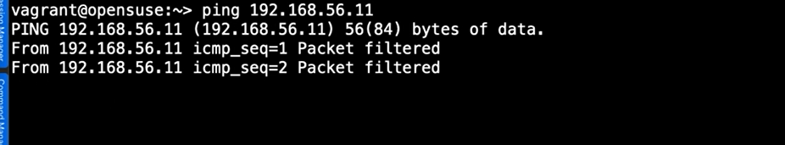

## Chapter 2.8: summary

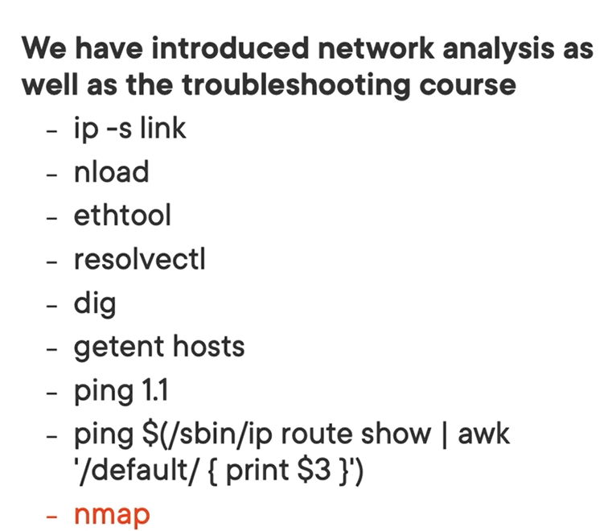

# Chapter 3: Troubleshooting Memory and CPU Issues

## Chapter 3.1: Installing Sysstat

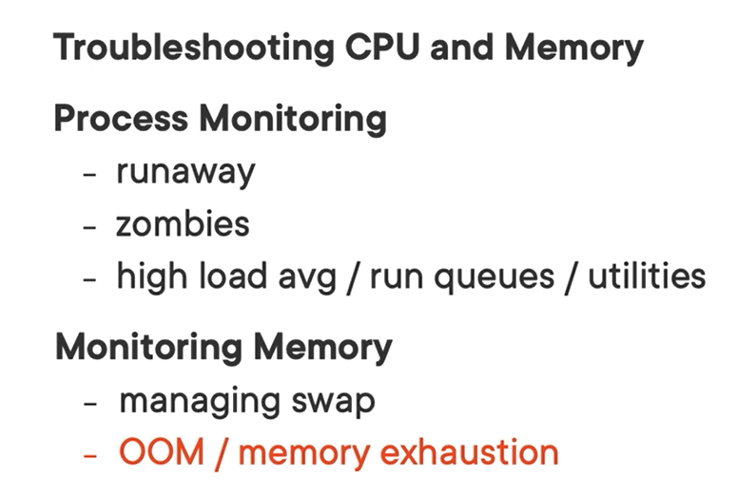

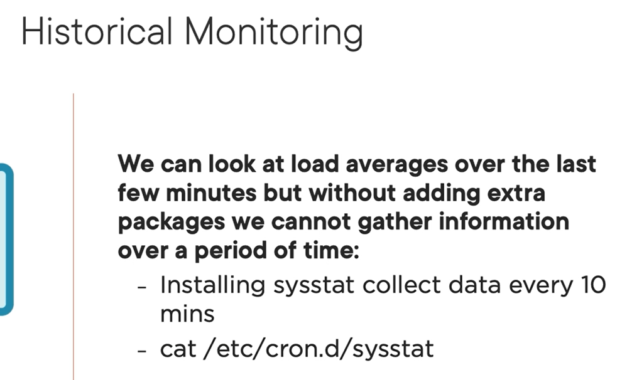

Demo

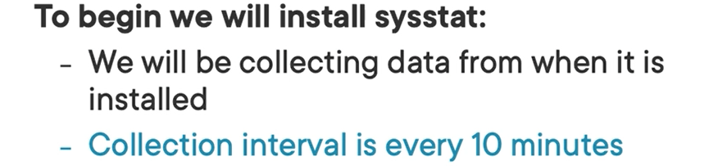

## Chapter 3.2: Understanding Uptime

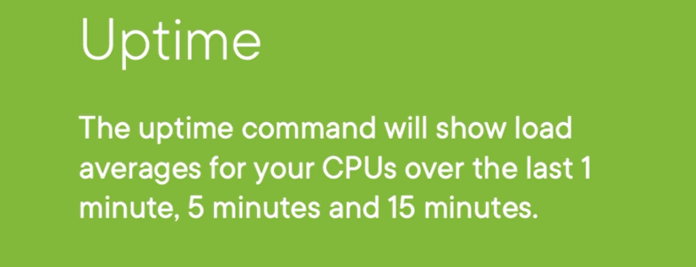

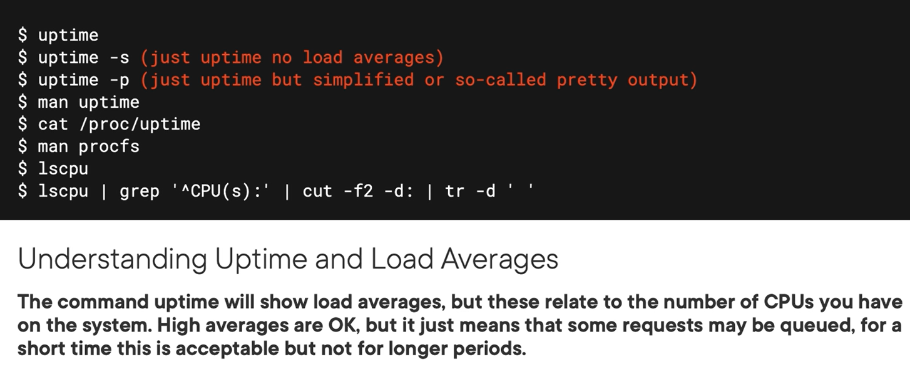

Demo

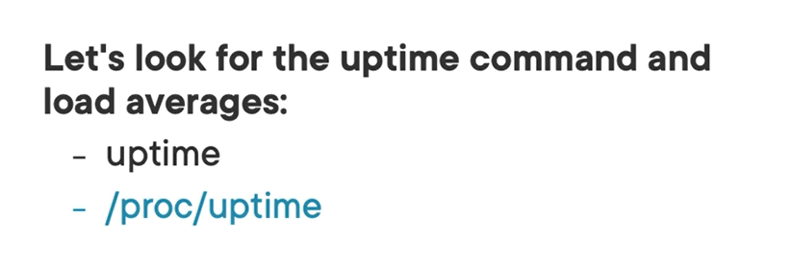

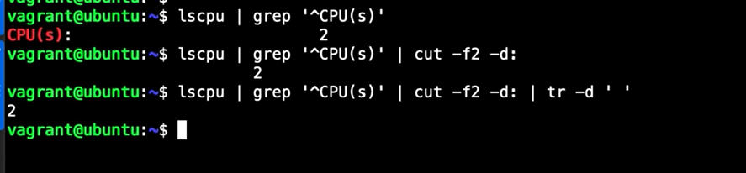

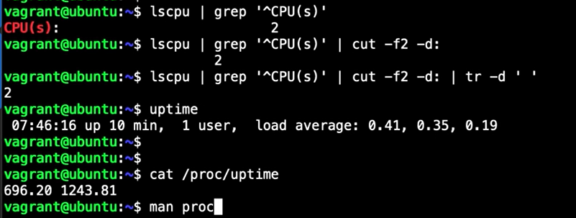

The results of “cat /proc/uptime” give me two item: uptime and idle time.

## Chapter 3.3: Working with Sar and Mpstat

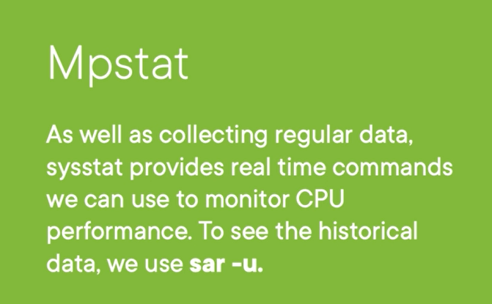

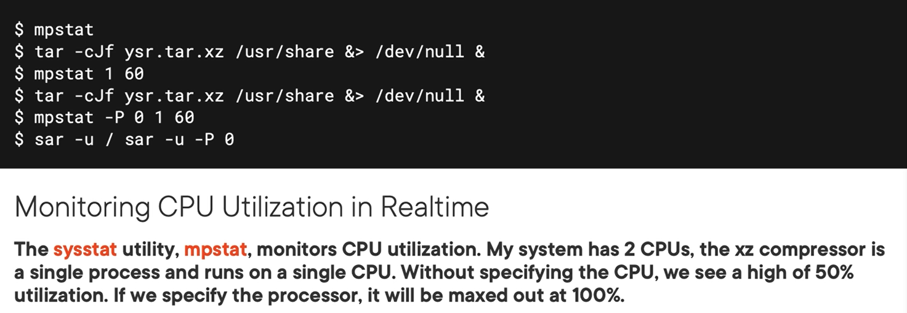

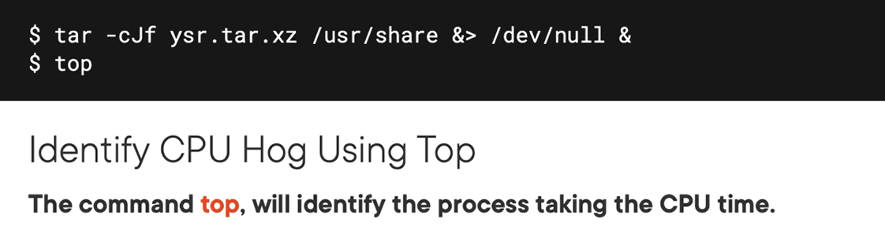

demo

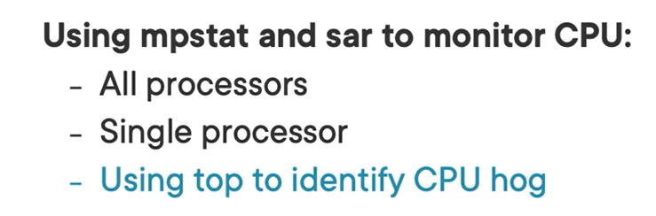

Checking with mpstat

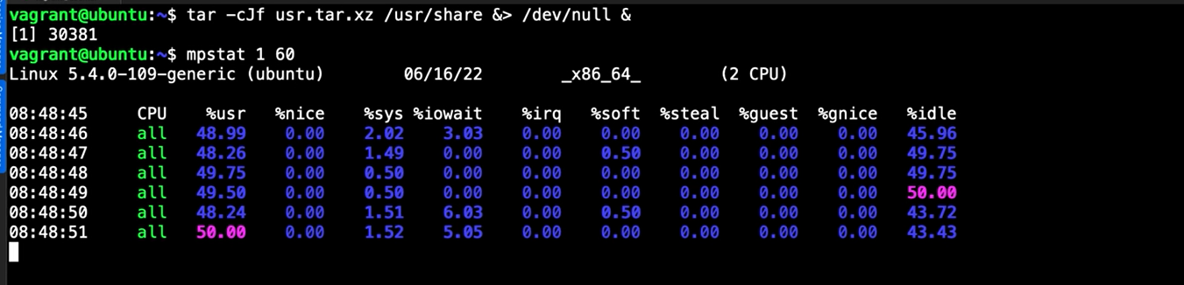

Checking performance of cpu 0

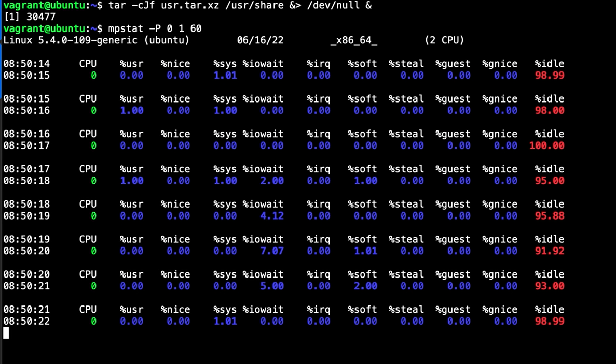

Checking utilization of cpu 1 – it seems to be busy

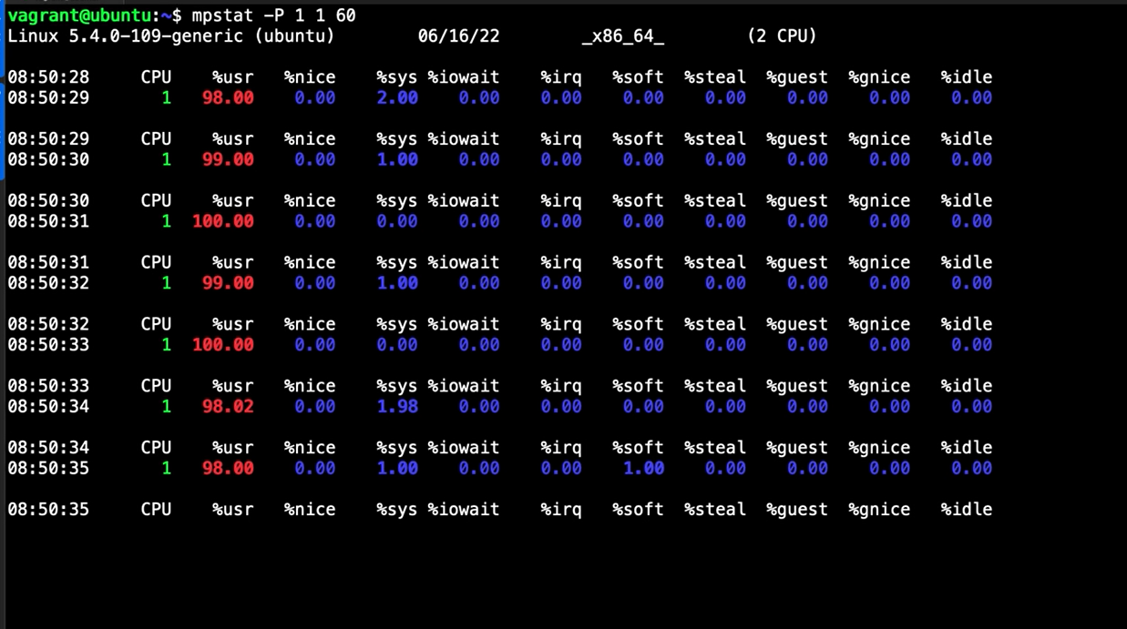

The other tool used to report the performance of cpu for long time: system activity report tool: sar

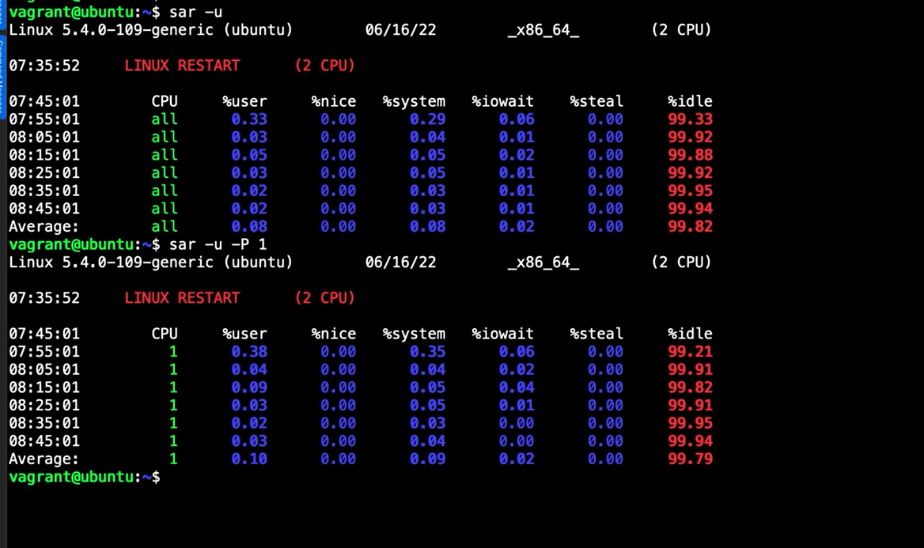

Top command will show you which command are utilize or hogging cpu



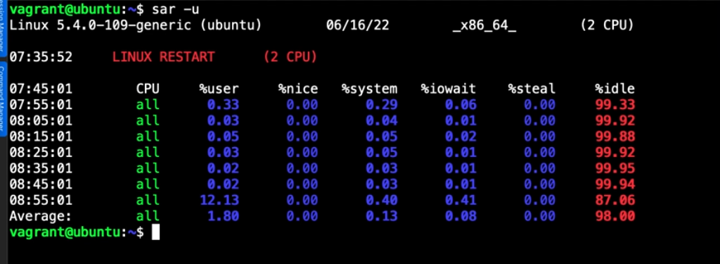

Also have some of options used with sar:

Sar -u // CPU

Sar -S // swap

Sar -r // ram

## Chapter 3.4: Understanding Zombie Processes

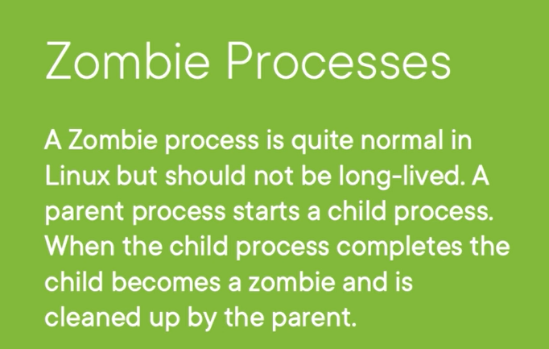

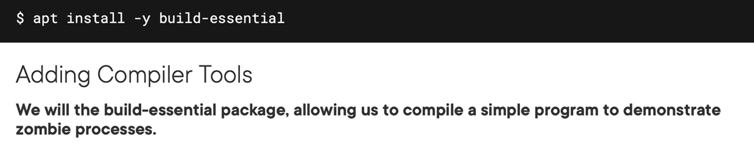

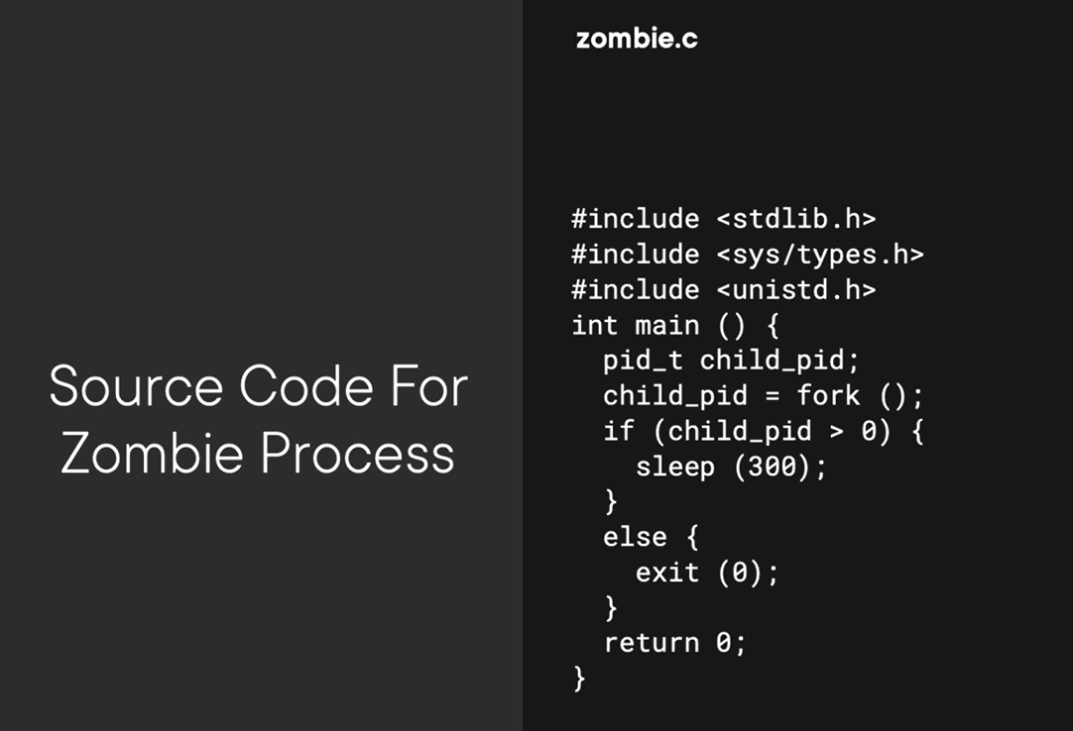



Demo

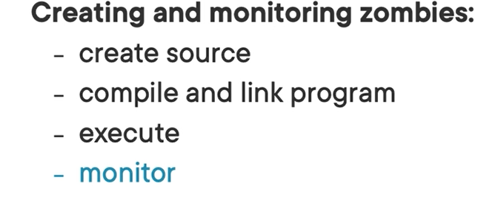

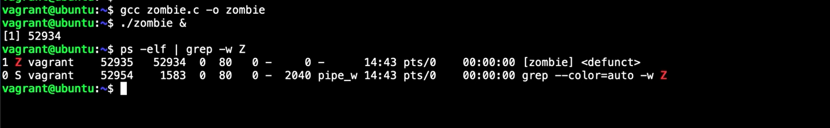

With zombies process you need to kill parent process instead of kill zombie process will cause that zombies process into hang on state

## Chapter 3.5: Troubleshooting Memory and OOM

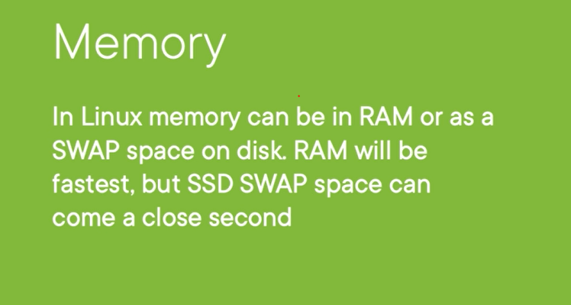

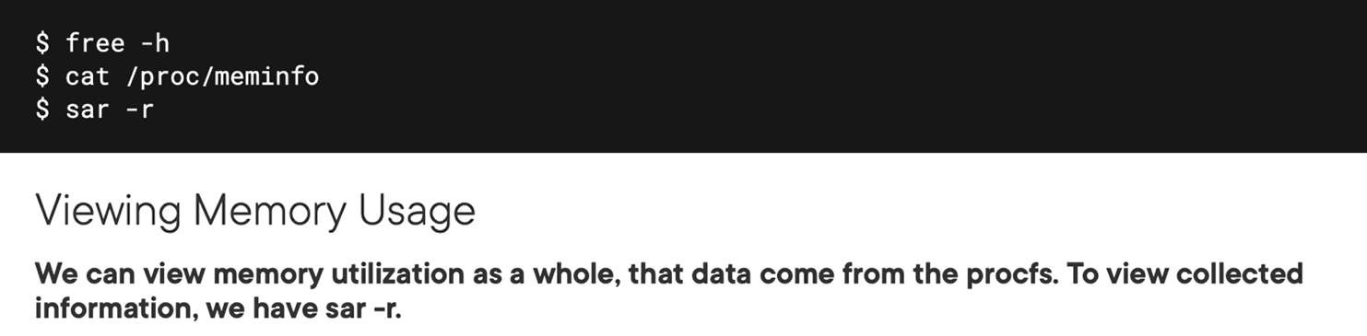

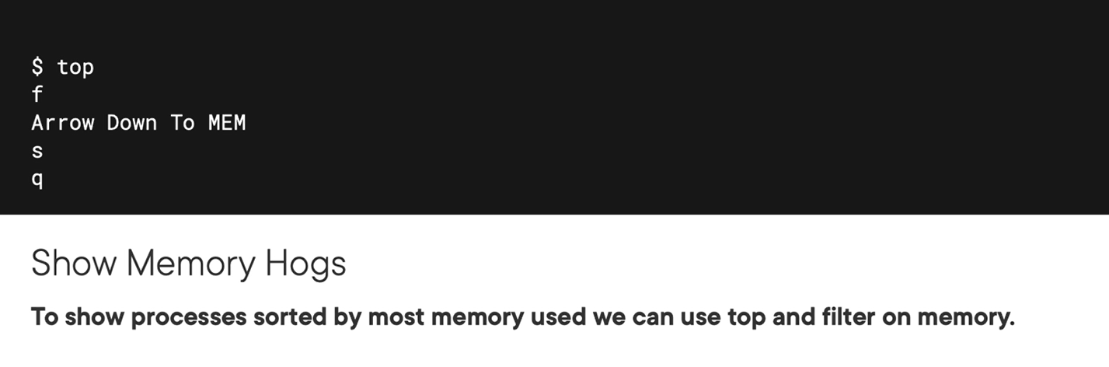

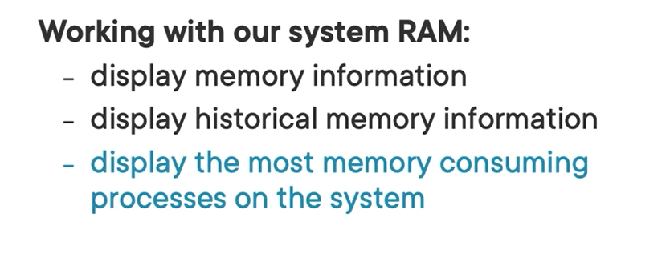

You can raw information of mem in procfs /proc/meminfo. It contains raw infor difficult than free -h command

## Chapter 3.6: Troubleshooting SWAP Memory

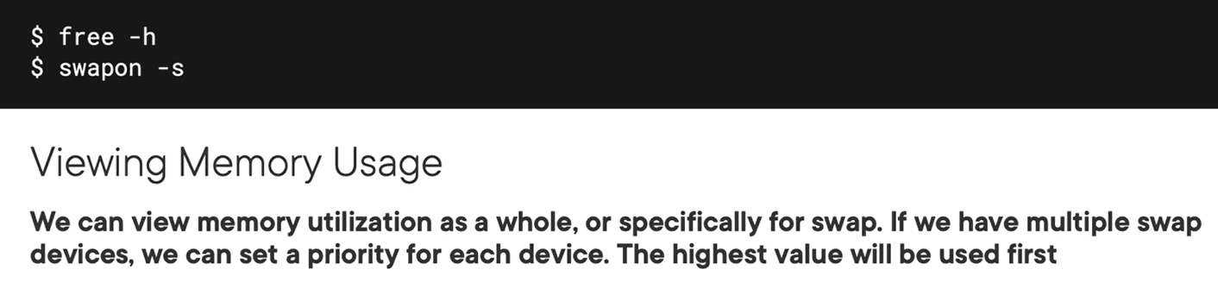

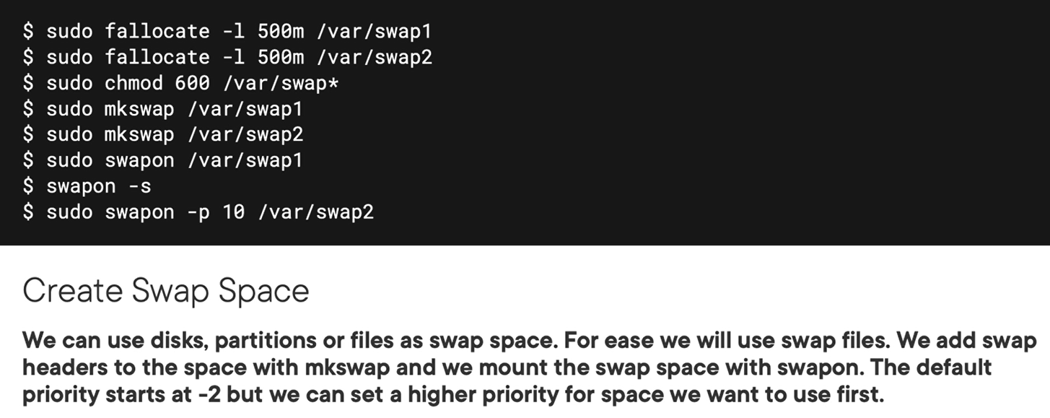

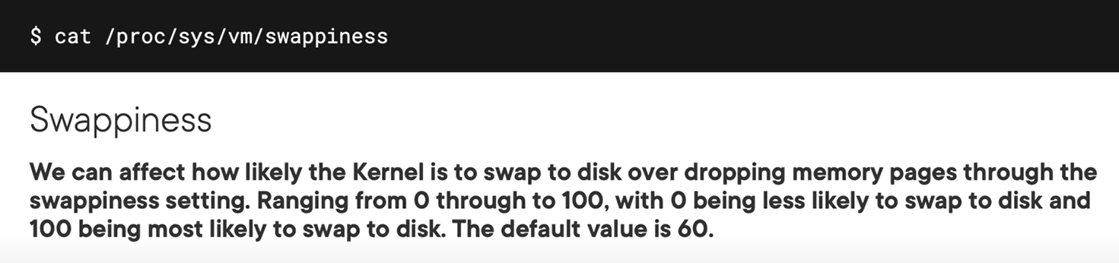

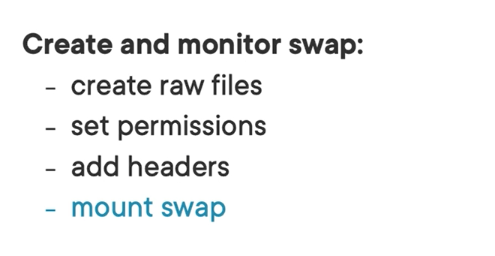

Demo

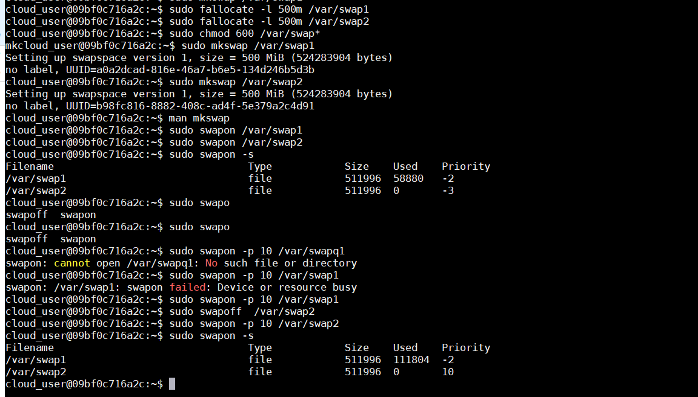

You can set the swapiness on /proc/sys/vm/swapiness to certain point which you want.   
and remember that need to be set on sysctl.d folder then reread the database “sysctl –system”

## Chapter 3.7: Summary

# Chapter 4: Troubleshoot Storage Issues

## Chapter 4.1: Testing IOPS with Loping

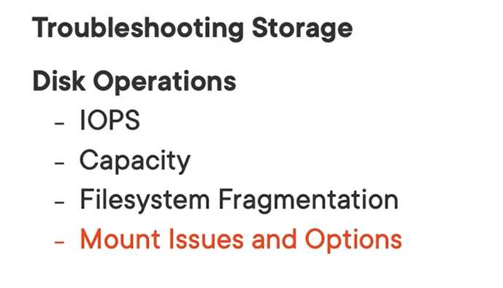

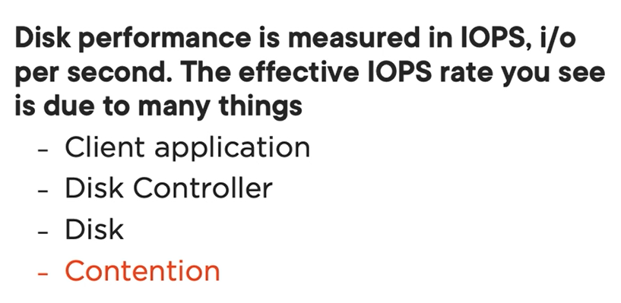

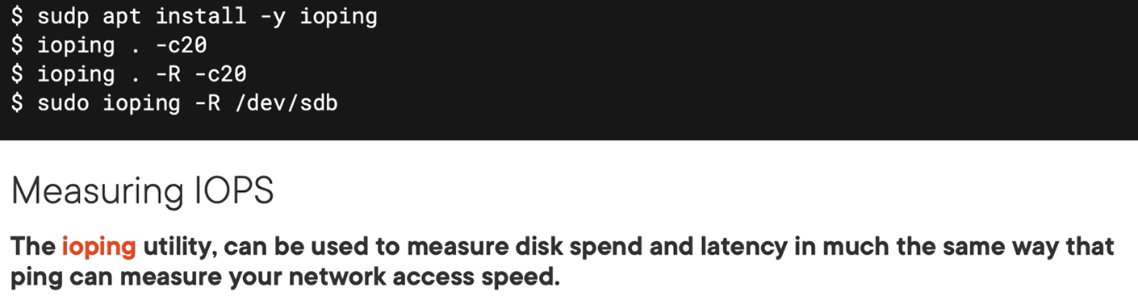

Ioping use to measure the io device files system or device speed

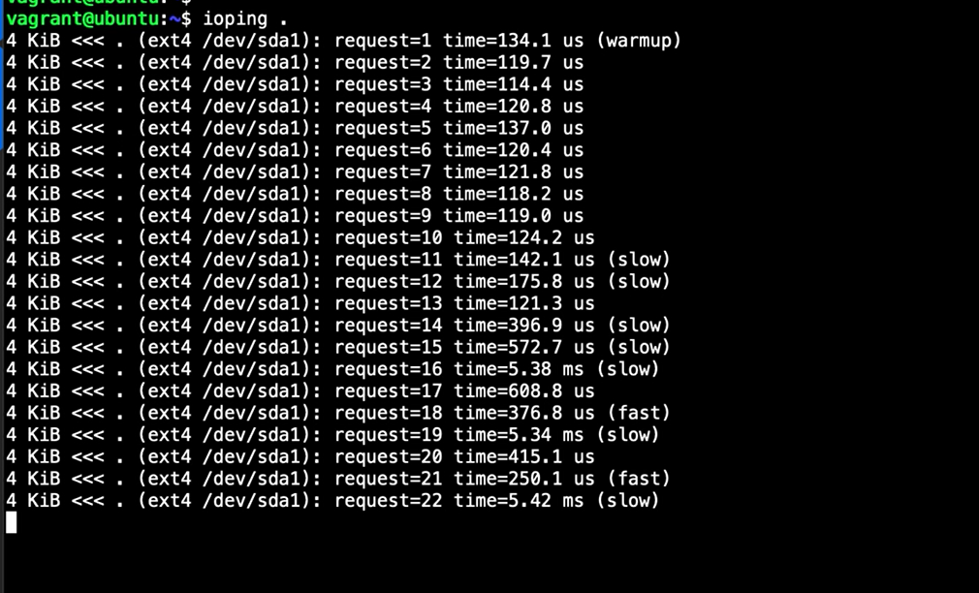

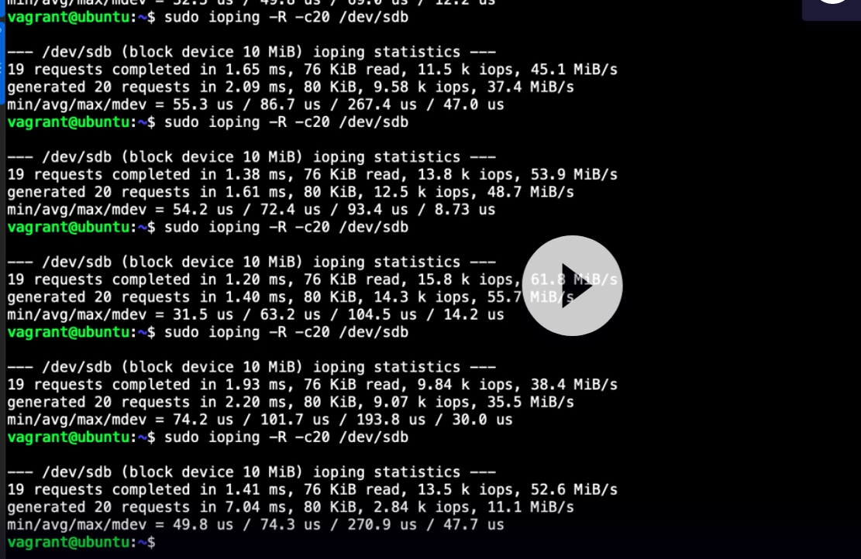

This tool useful for determine which space faster than one to choise for using swap file system or swap data.

## Chapter 4.2: Reading Disk Performance with Sar

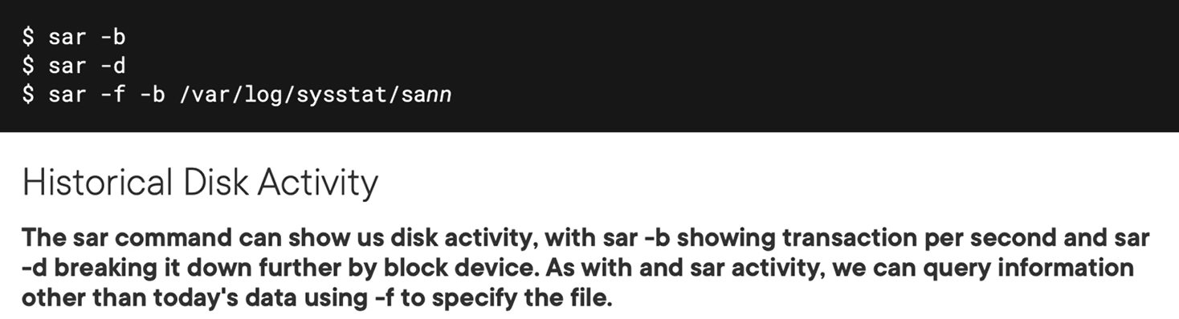

Demo

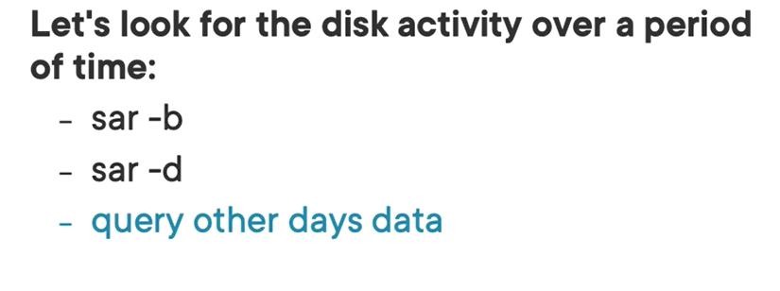

Sar -b // summary information of disk today

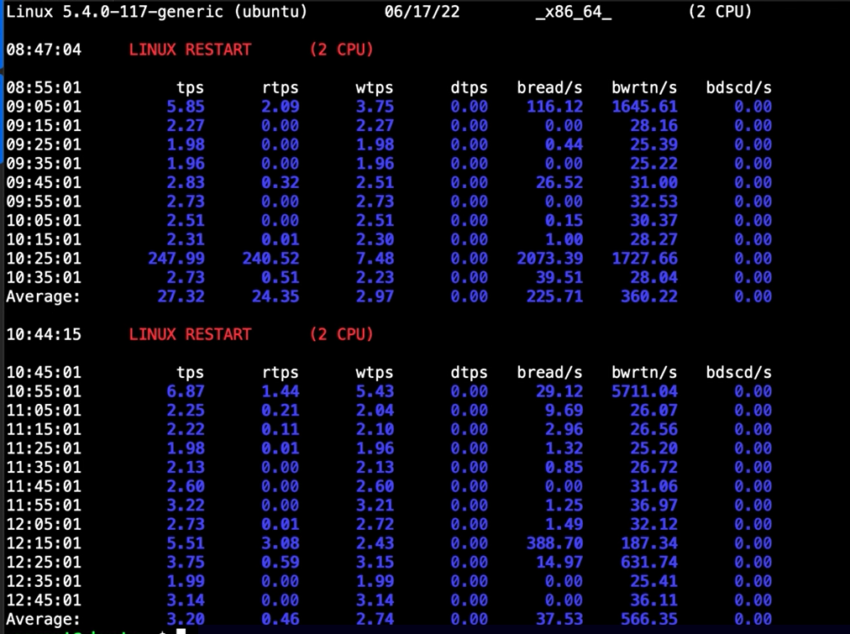

Sar -b -f /var/log/sysstat/sa16 // summary information of disk another day

Use -f for individual block

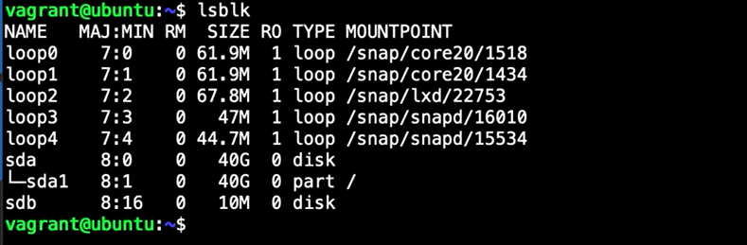

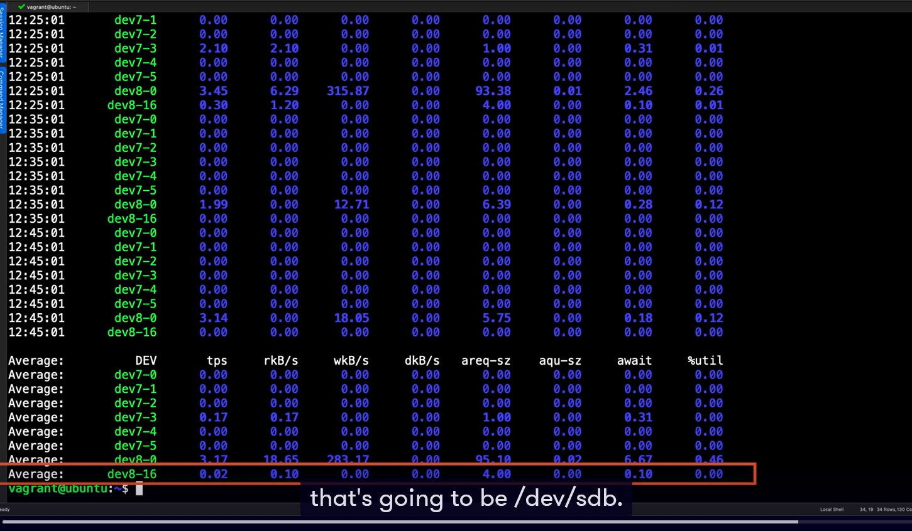

## Chapter 4.3: Disk Defragmentation

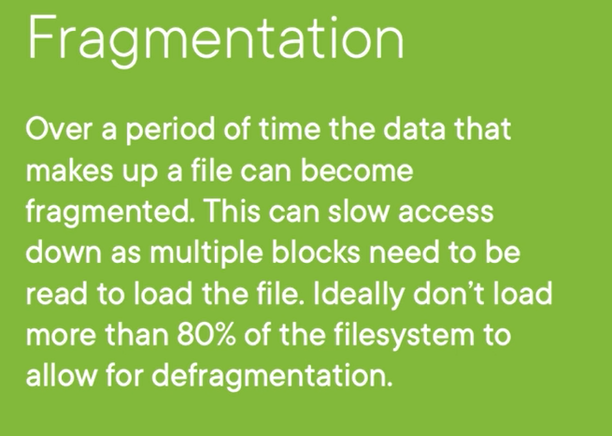

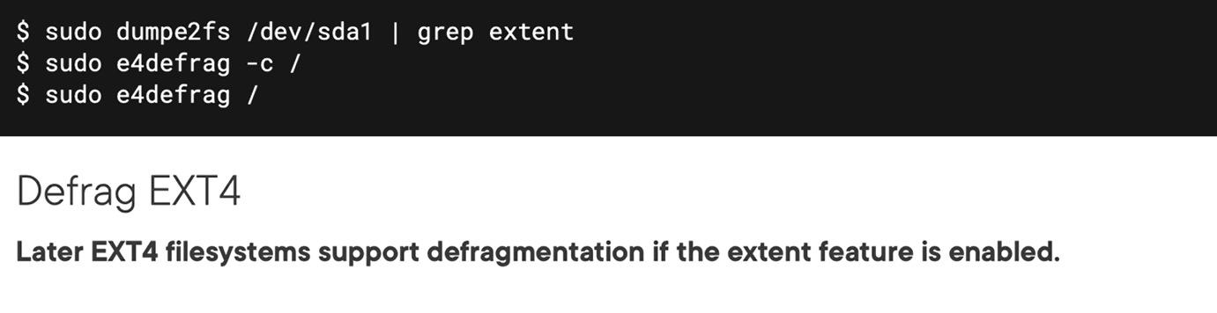

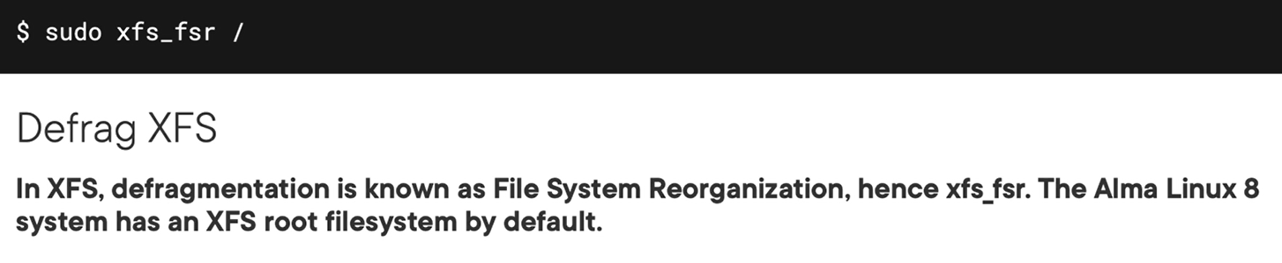

Demo

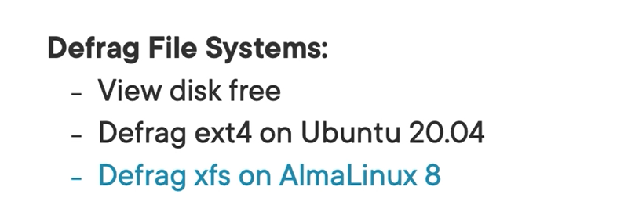

After we have file system information, we enter:

Dumpe2fs /dev/sda1 | grep extent

For checking all metadata



Checking the partion if need defrag

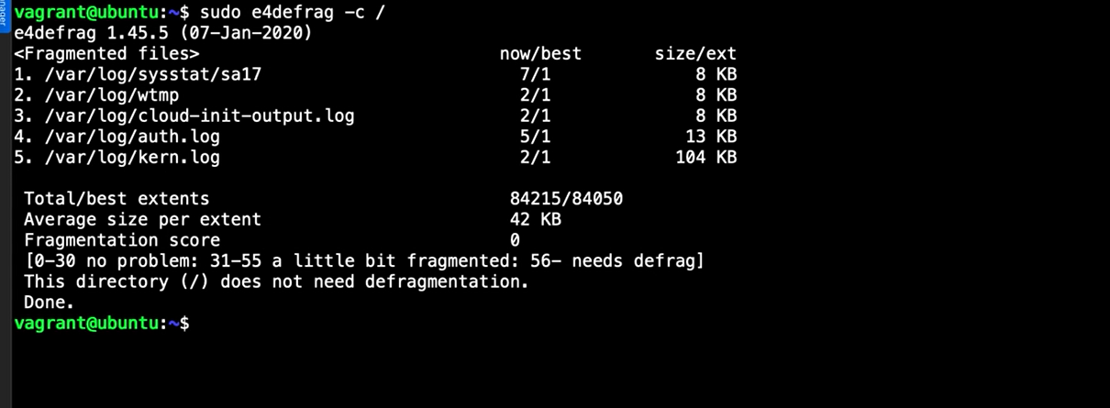

As above screen we can score above 56 need to defrag. And remove “-c” option to take defrag.

Move on to xfs file system (rehl)

Checking if need defrag

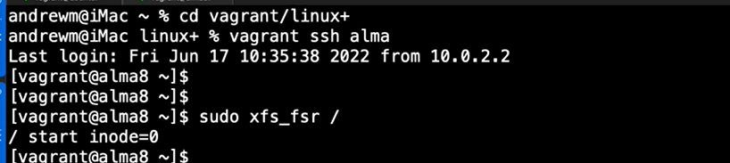

## Chapter 4.4: Configuring Mount Options

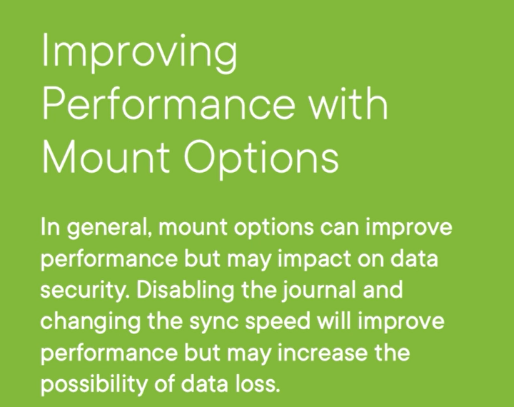

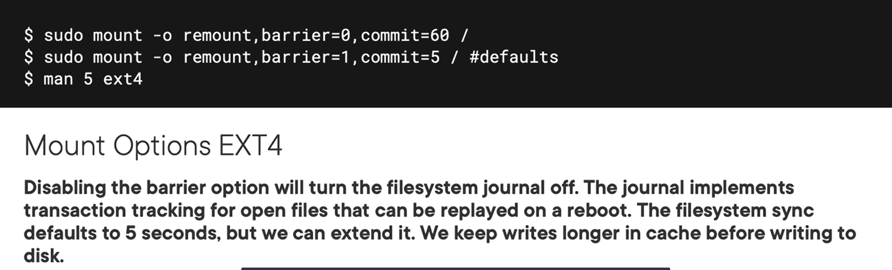

Demo

Checking mount system

Mount -t ext4 // checking file system is ext4 on system

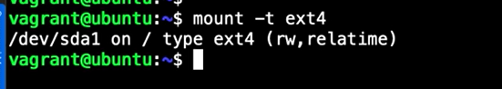

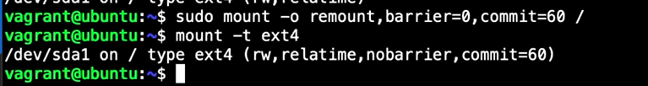

## Chapter 4.5: Summary and What's Next

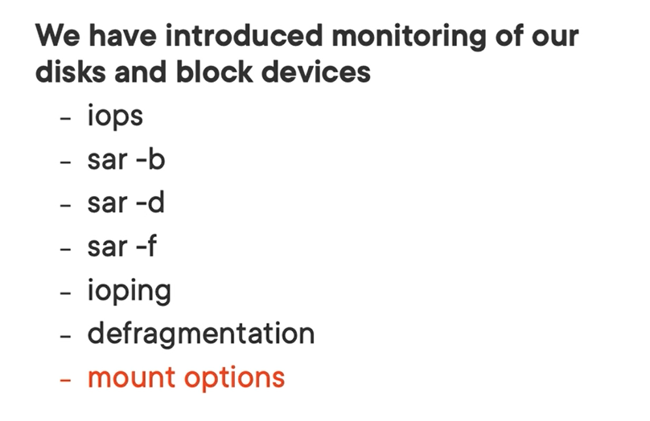

# Chapter 5: Troubleshoot User Access

## Chapter 5.1: Welcome to Troubleshooting User Access

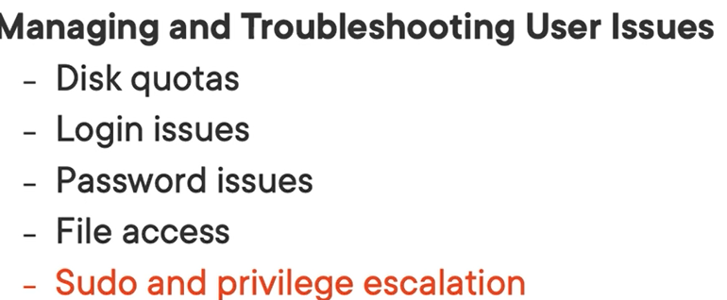

Disk quotas

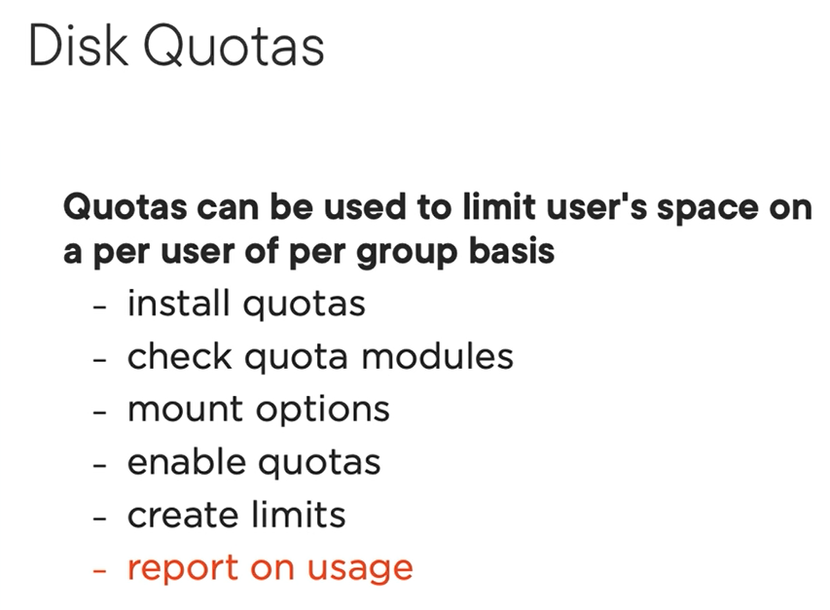

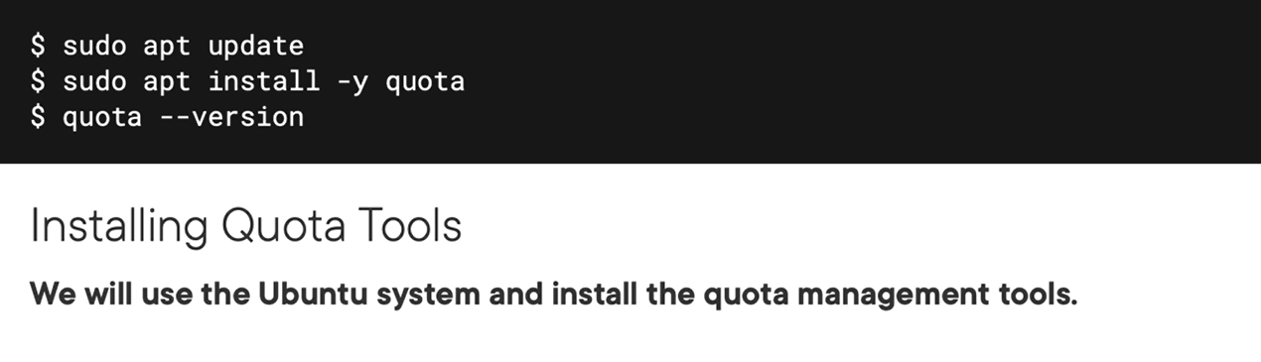

If you are using vagrant maybe need install bellow package

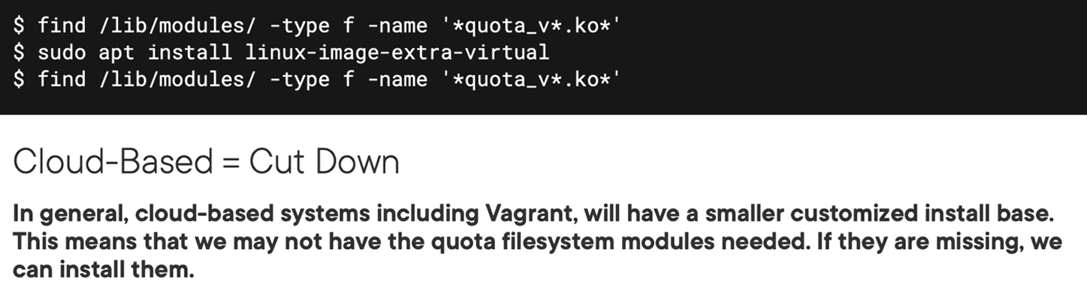

## Chapter 5.2: Installing Quota Systems

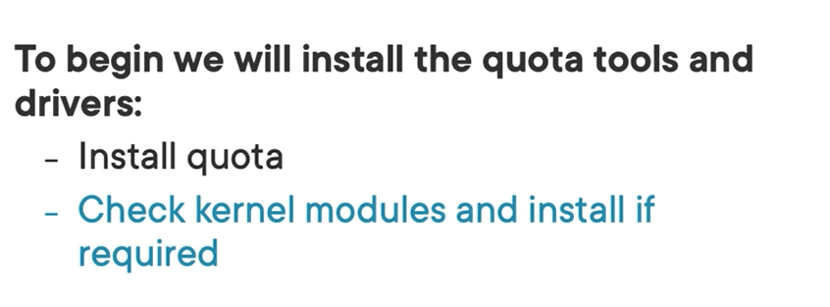

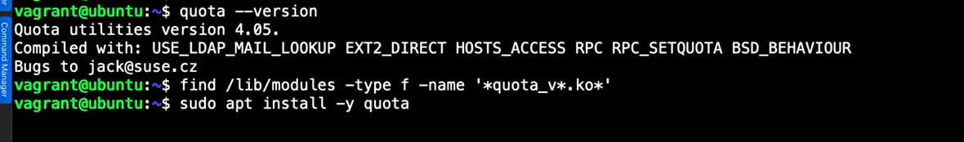

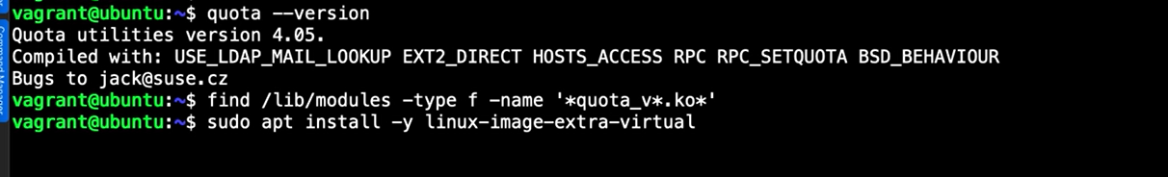

Tip for finding old commands

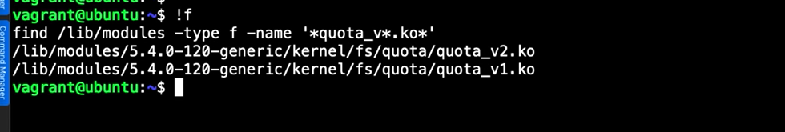

## Chapter 5.3: Understanding How Quotas Are Configured

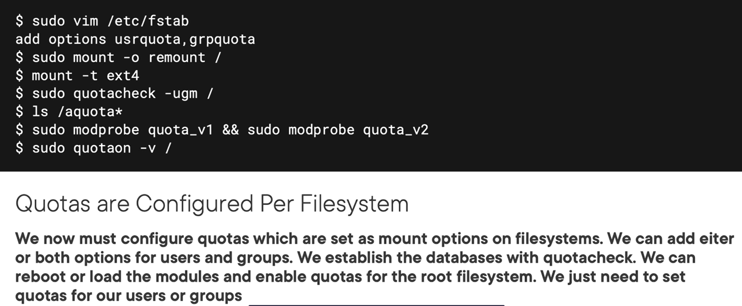

## Chapter 5.4: Configuring User Quotas

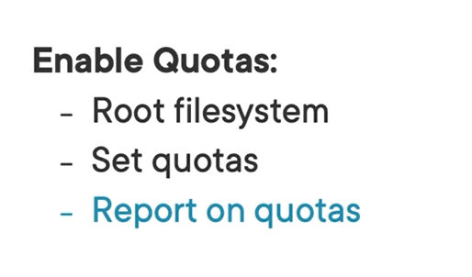

Change fstable of / partition form default to userquota

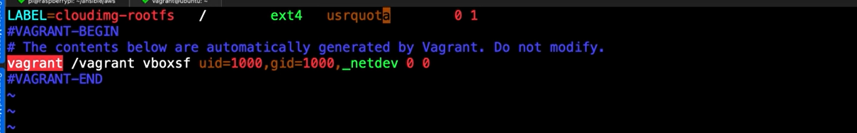

Remount for take effectively

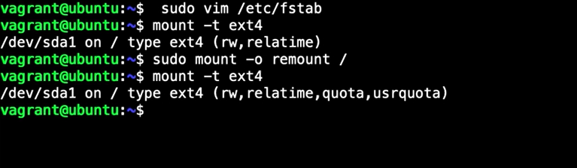

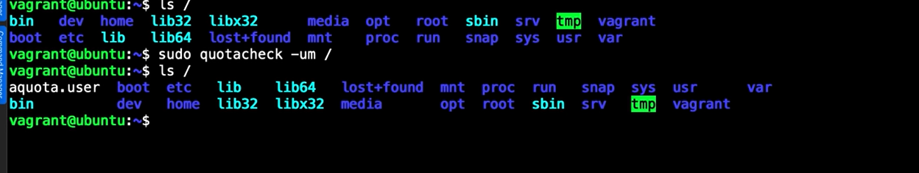

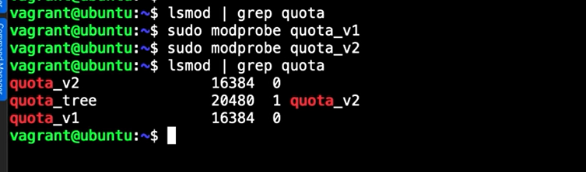

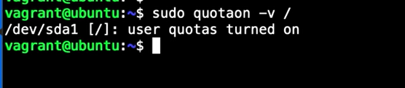

Report on quotas

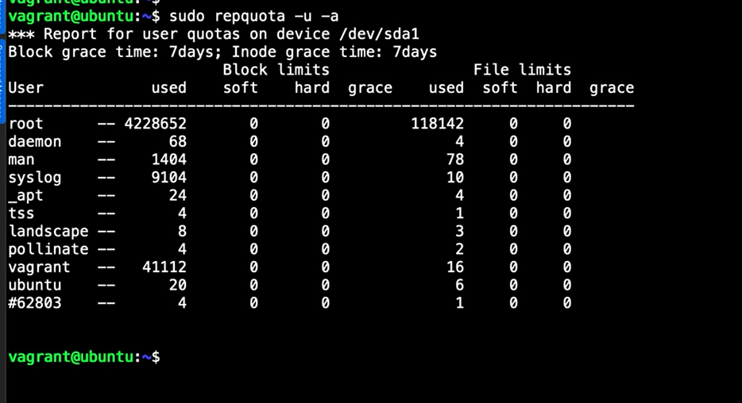

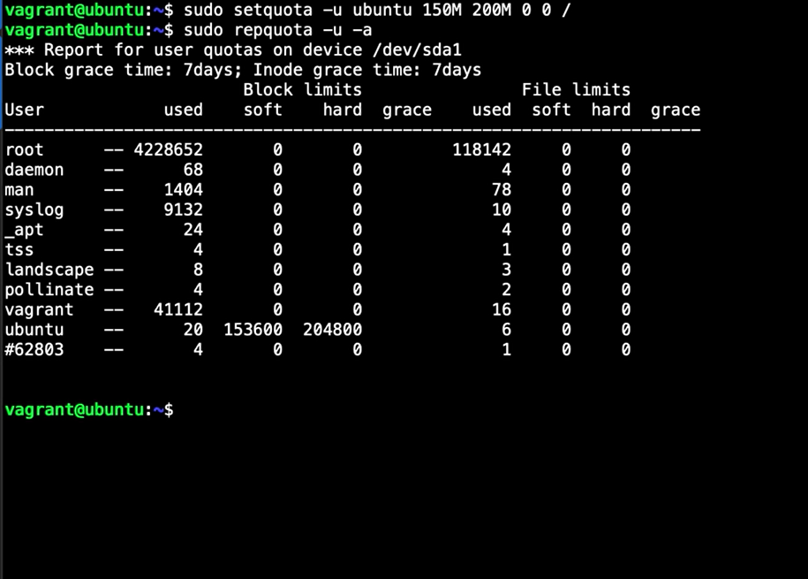

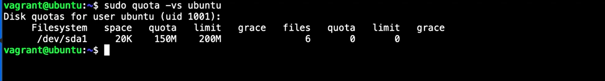

Grace period default is 7 days

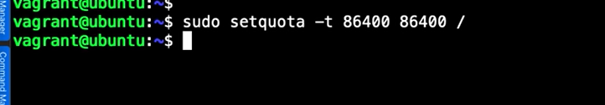

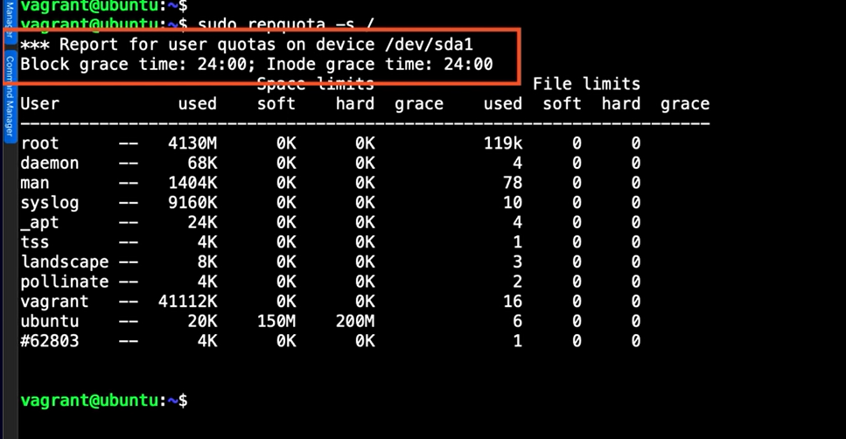

Sudo – ubuntu for testing

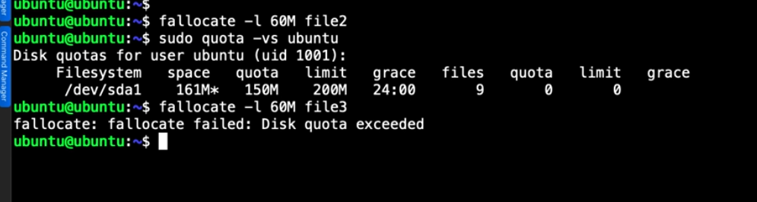

## Chapter 5.5: Diagnose Login Issues

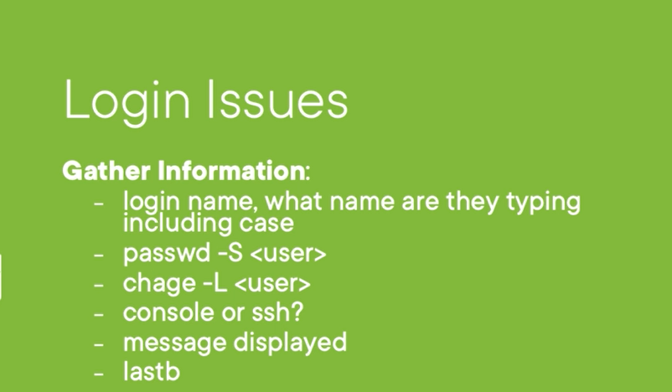

Demo

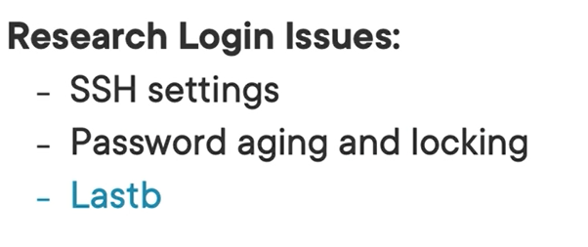

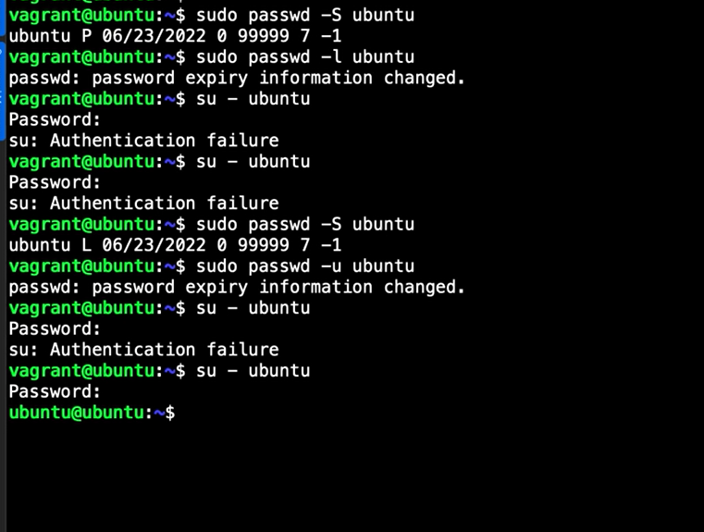

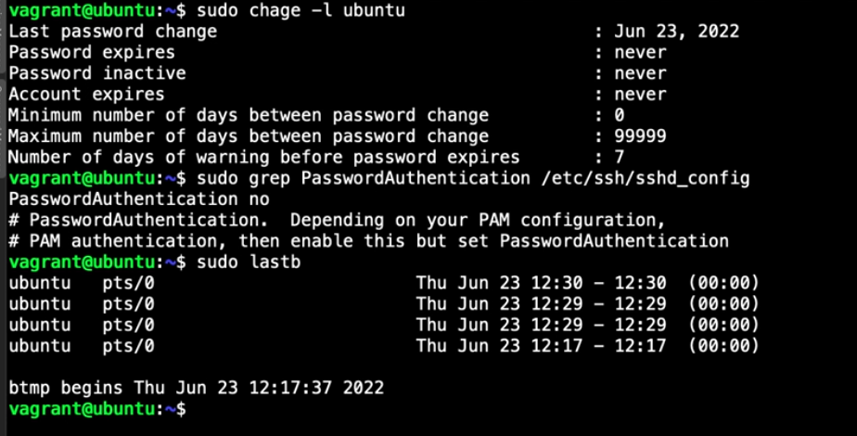

## Chapter 5.6: Understanding Default Password Complexity



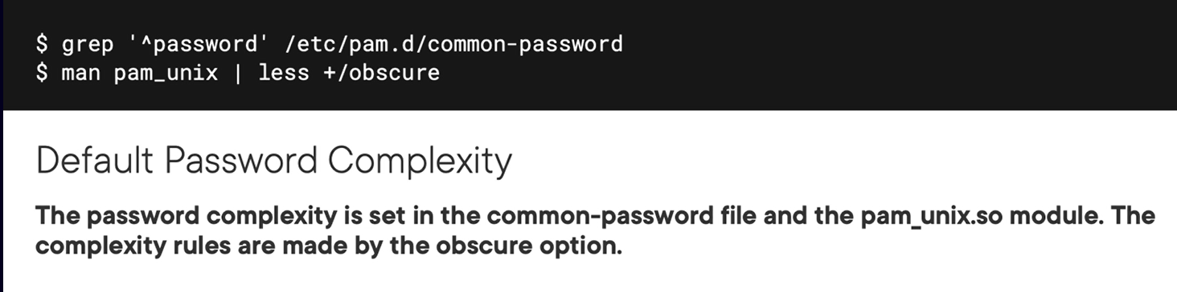

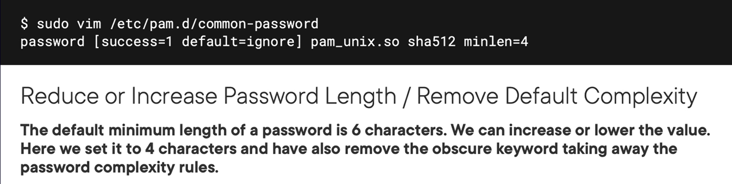

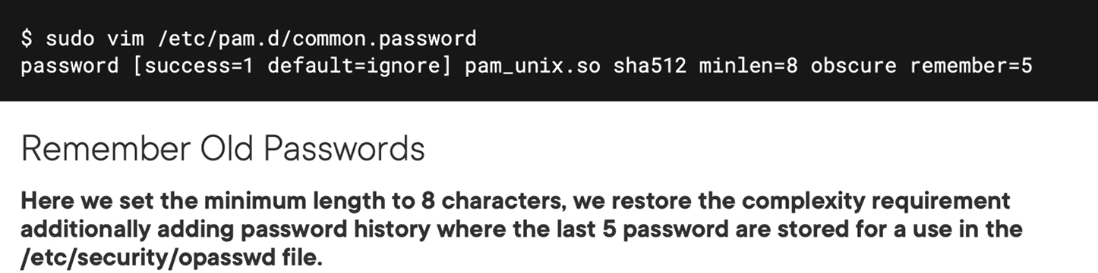

## Chapter 5.7: Configuring Password Complexity

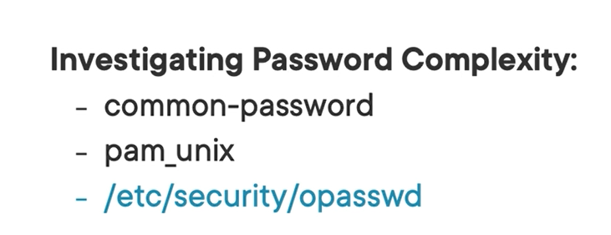

Note: PAM pluggable authentication module

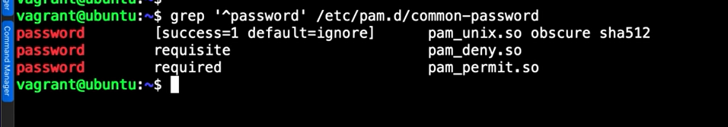

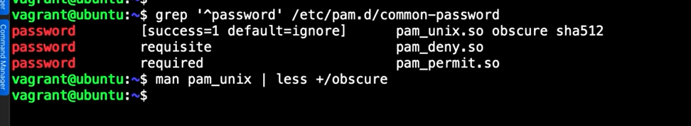

You want to change the obscure of password

Vi /etc/pam.d/common-passwrod

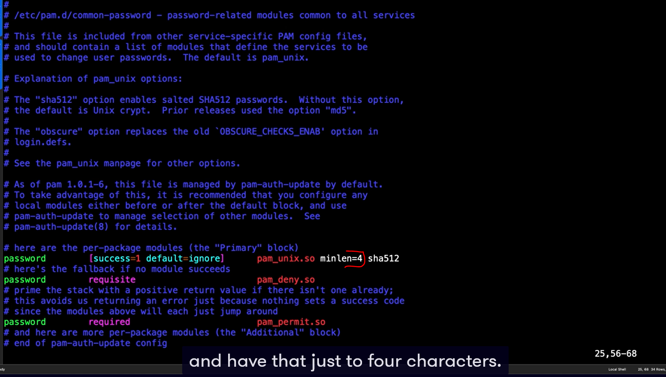

To view old password

Cat /etc/security/opassword

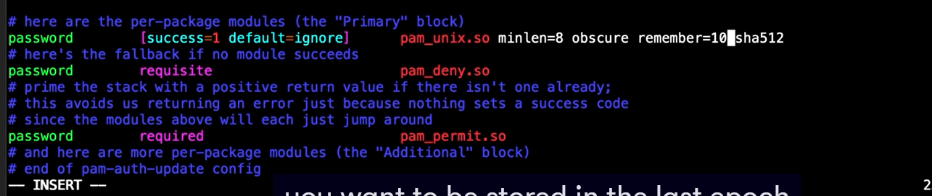

After change parameter in /etc/pam.d/common-password



## Chapter 5.8: Troubleshooting User Access

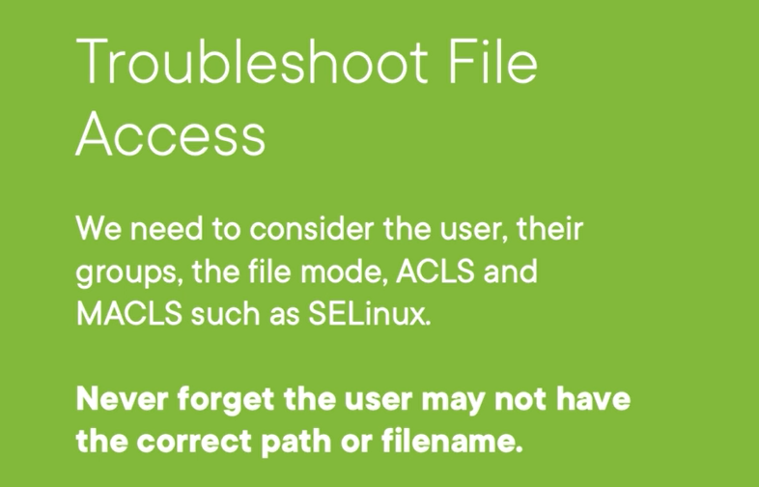

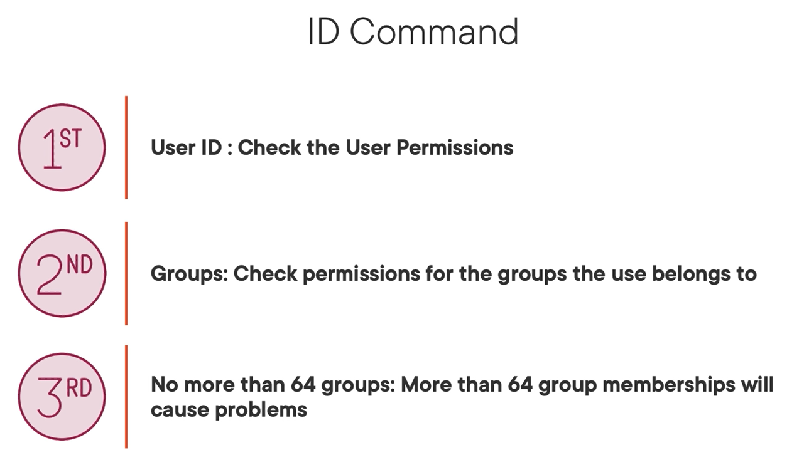

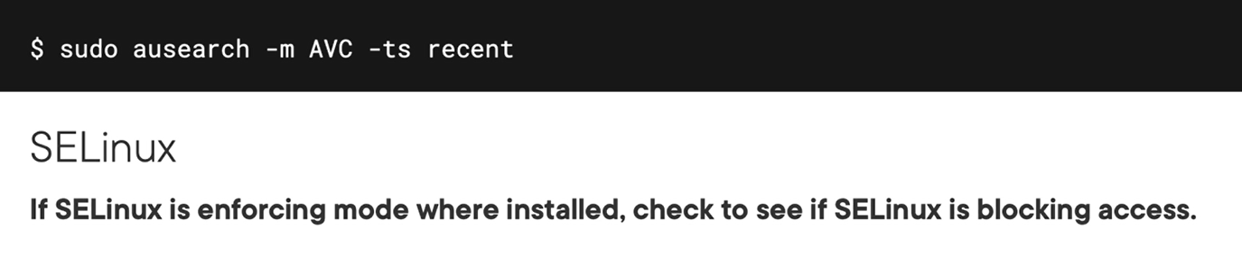

## Chapter 5.9: Troubleshooting Sudo

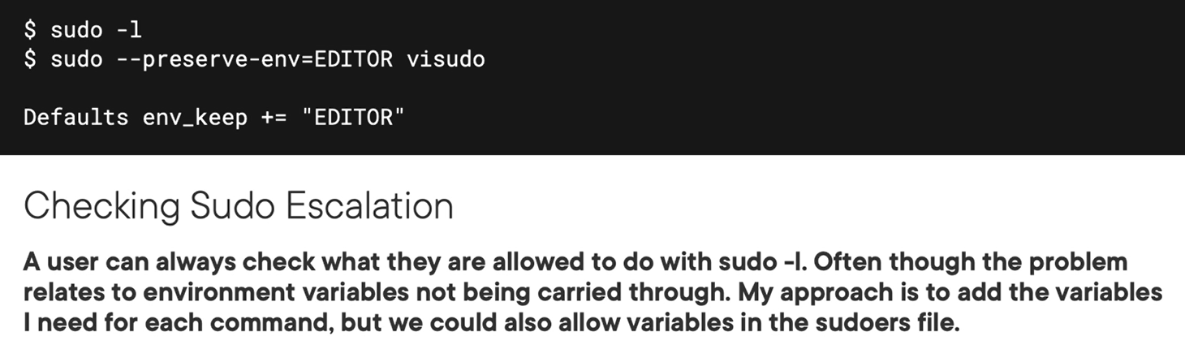

demo

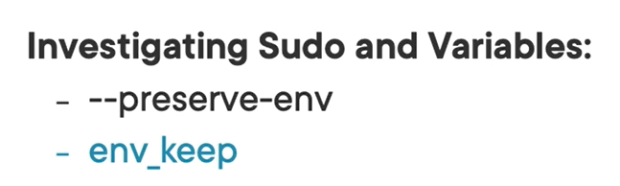

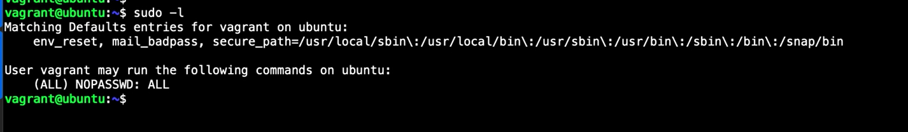

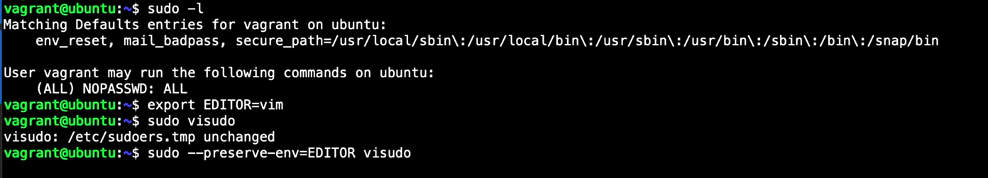

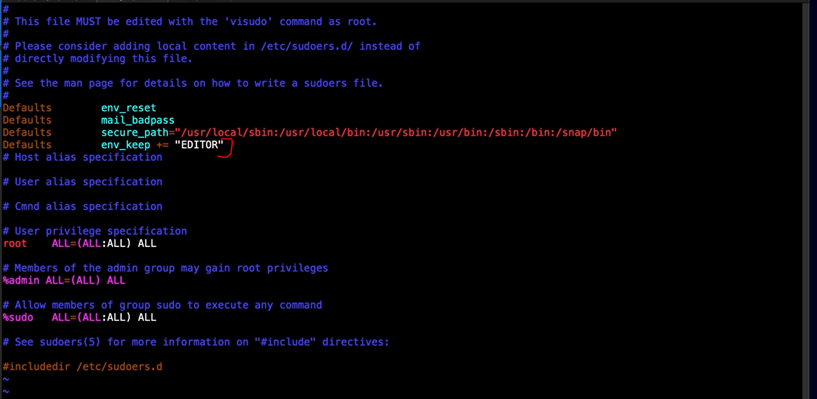

## Chapter 5.10: Summary and What's Next

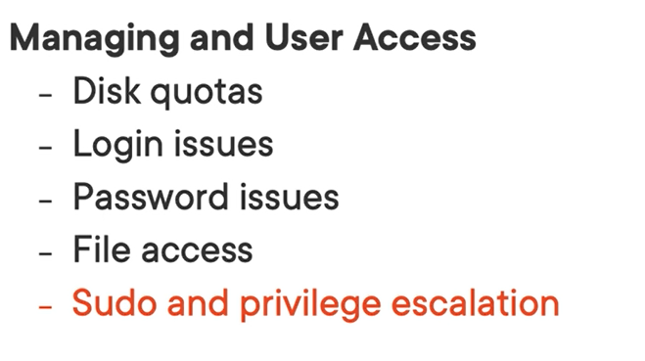

# Chapter 6: Diagnose Issues Using Systemd

## Chapter 6.1: Analyzing System Startup

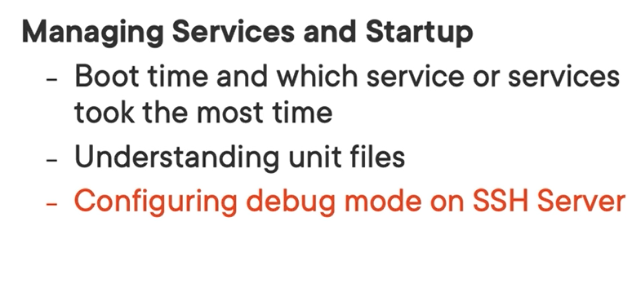

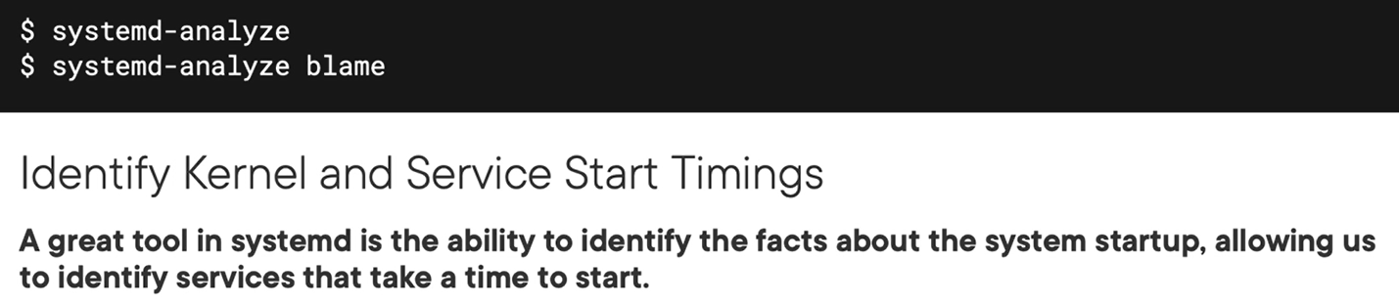



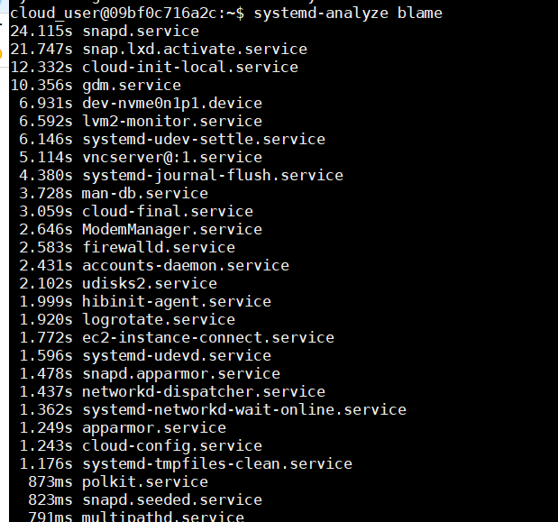

## Chapter 6.2: Understanding Service Units

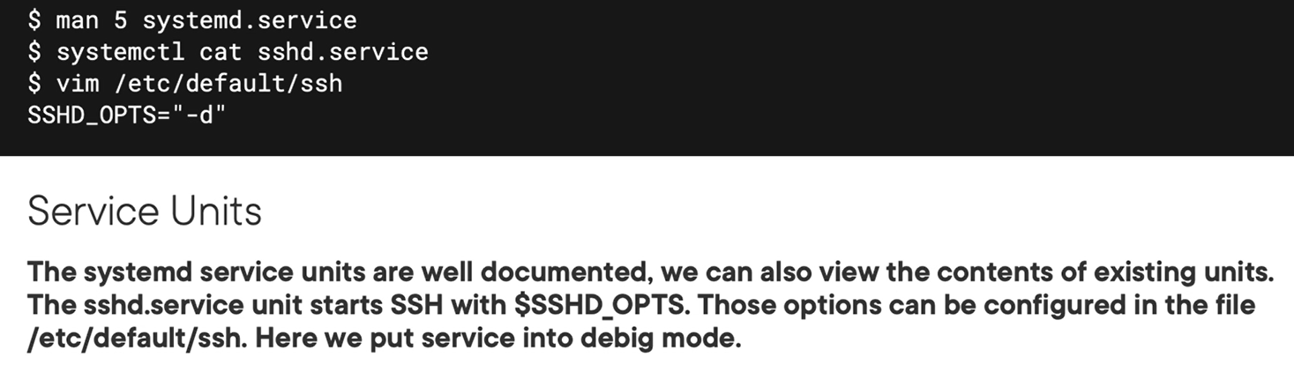

Demo

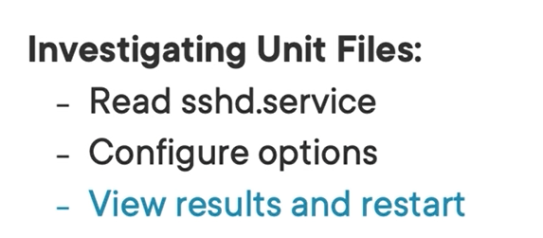

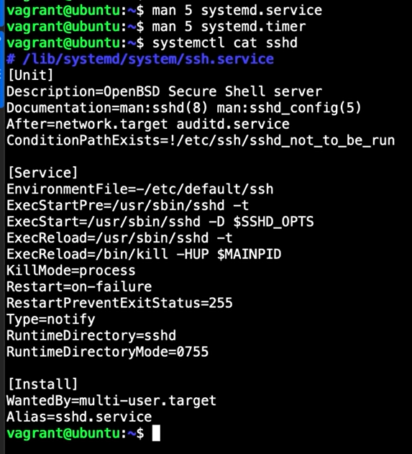

If you want to debug ssh service,



## Chapter 6.3: Summary

# Resource

<https://learn.acloud.guru/course/931f50d4-02bf-4073-87b0-ae119b2aaf54/overview>